# Semiconductor Packaging

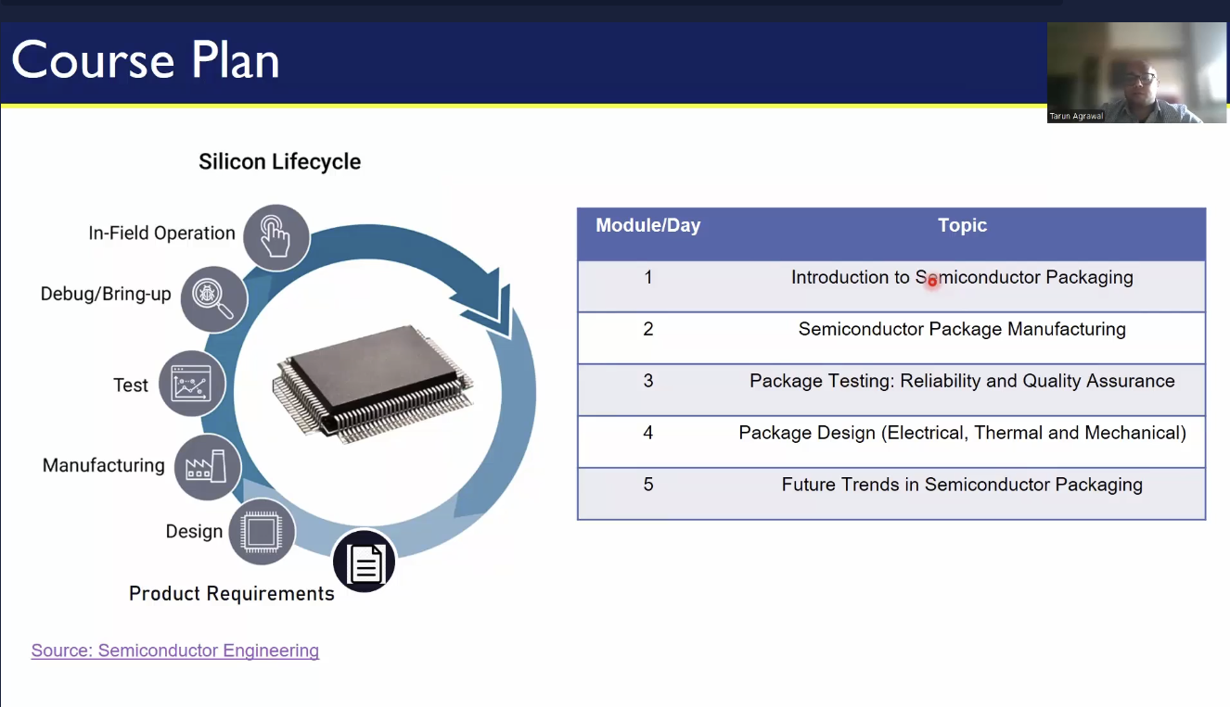

## Packaging Evolution: From Basics to 3D Integration

## Introduction to Semiconductor Packaging and Industry Overview

### 📦 Why is Semiconductor Packaging needed?

Semiconductor chips comprising of extremely small components, are manufactured at a very controlled and protected environment. Semiconductor packaging is crucial for transferring a fragile, fabricated silicon die from a controlled, cleanroom environment to the real-world electronics. Since bare dies from foundries like Intel, TSMC, or Samsung are delicate, packaging protects them from moisture, physical damage, and other environmental factors allowing them to function properly in electronic devices.

### 🛡️ Key Functions of Packaging

* Protection of the semiconductor devices on the die from physical damage, moisture, dust, and corrosion, ensuring the die remains safe during handling, transport, and operation
* Electrical Connectivity (pins, balls, or leads) that link the chip to the rest of the system, enabling power and data transfer
* Thermal Management by dissipating heat generated by the chip during operation, preventing overheating and ensuring optimal performance and longevity These functions together enable the semiconductor chip to operate effectively and reliably in real-world devices.

### 🧠 Real-World Example

A real-world example of semiconductor packaging can be found in smartphones. Let’s take the Apple A-series chip packaging (e.g., A14, A15, A16 Bionic), commonly used in iPhones. The A-series chip is packaged in a System in Package (SiP) configuration. The chip package has small solder balls underneath (in this case, a Ball Grid Array (BGA) configuration) that connect the chip to the motherboard of the phone. These solder balls create the electrical links that allow the chip to communicate with other components like memory, sensors, and the display. So, the semiconductor packaging in the Apple A-series chip ensures the chip is protected, connected, thermally managed, mechanically stable, and reliable—allowing the phone to function at high performance while enduring real-world conditions. This same concept applies to many other devices, including computers, tablets, and wearables.

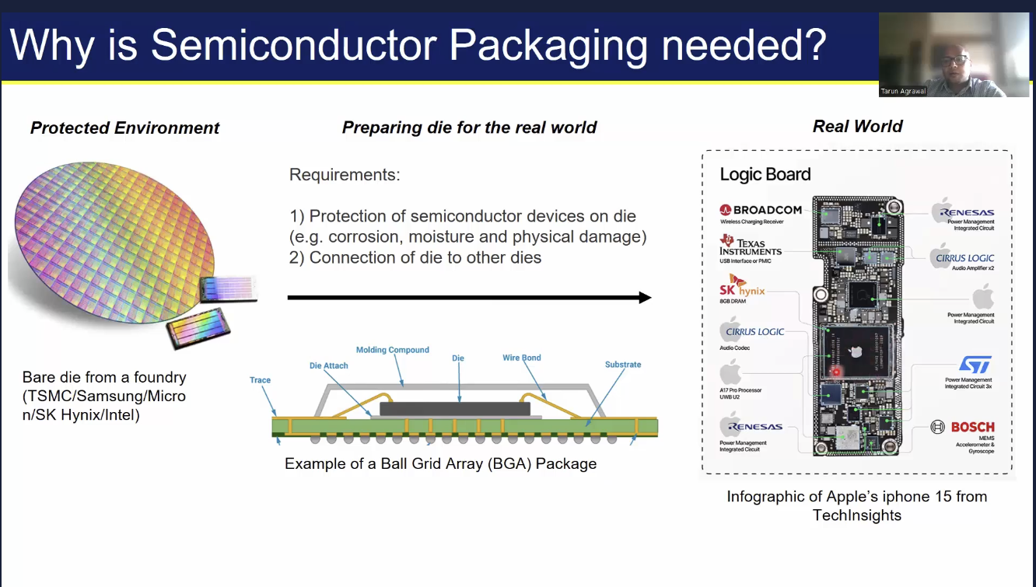

### 🏭 Semiconductor Industry Segments

A semiconductor ecosystem is an entire network of industries, technologies, companies, and processes involved in the creation, manufacturing, and deployment of semiconductor devices. It includes everything from the raw materials used to make semiconductors, to the research and development (R&D) efforts that push innovation, to the manufacturing and packaging processes that bring chips into the real world, and finally, the industries and applications that use these chips.

* Fabless companies are semiconductor companies that design and develop chips but do not have their own manufacturing facilities (known as fabs). Instead, they outsource the actual manufacturing (or "fabrication") of their chips to third-party foundries, also known as contract manufacturers or semiconductor fabs. This model allows fabless companies to focus on chip design and innovation without the enormous capital investment required for semiconductor fabrication. Example: Qualcomm, AMD, NVIDIA, etc.
* Foundries produce integrated circuits (ICs) based on designs provided by other companies, known as fabless companies. Foundries do not design chips themselves but focus on the production process, which involves transforming raw materials (such as silicon) into functional semiconductor components using advanced manufacturing techniques. Example: TSMC, Samsung, etc.
* OSAT stands for Outsourced Semiconductor Assembly and Test. It refers to companies that specialize in the assembly (packaging) and testing of semiconductor devices, but do not engage in the actual fabrication of the semiconductor chips themselves. This sector ensures that the chips are properly enclosed (packaged) to protect them from environmental factors and ready them for integration into electronic devices. Additionally, testing is crucial to verify that each chip functions as intended, meets quality standards, and is free from defects. Example: ASE Group, Amkor Technology, JCET Group, etc.
* IDM (Integrated Device Manufacturer) companies design, manufacture, assemble, and test their own semiconductor devices. This vertical integration allows IDMs to have full control over their product quality, cost, and production timelines.

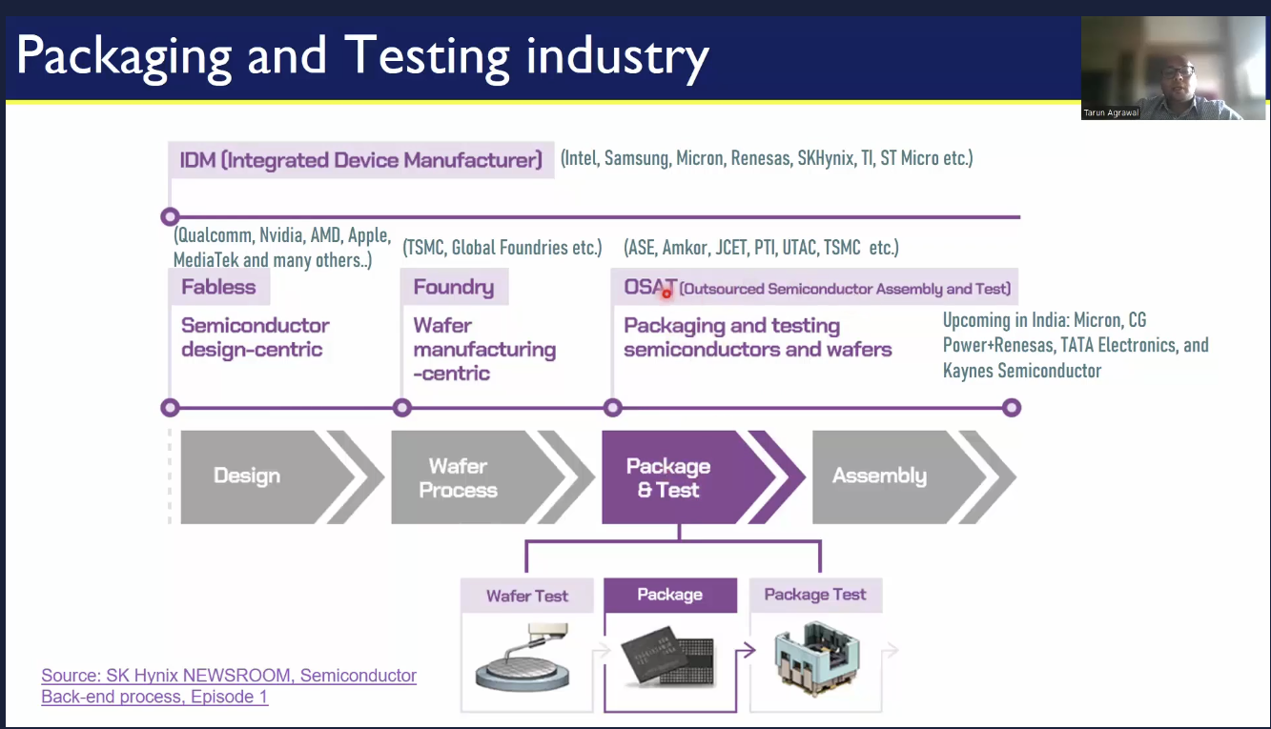

## Understanding Package Requirements and Foundational Package Types

### 📌 Package Requirements

In System on Chip (SoC) design, selecting the appropriate package plays a vital role in achieving optimal reliability, efficiency, and performance. As illustrated below, the package serves as a critical interface between the chip and the board, maintaining electrical, thermal, and mechanical integrity.

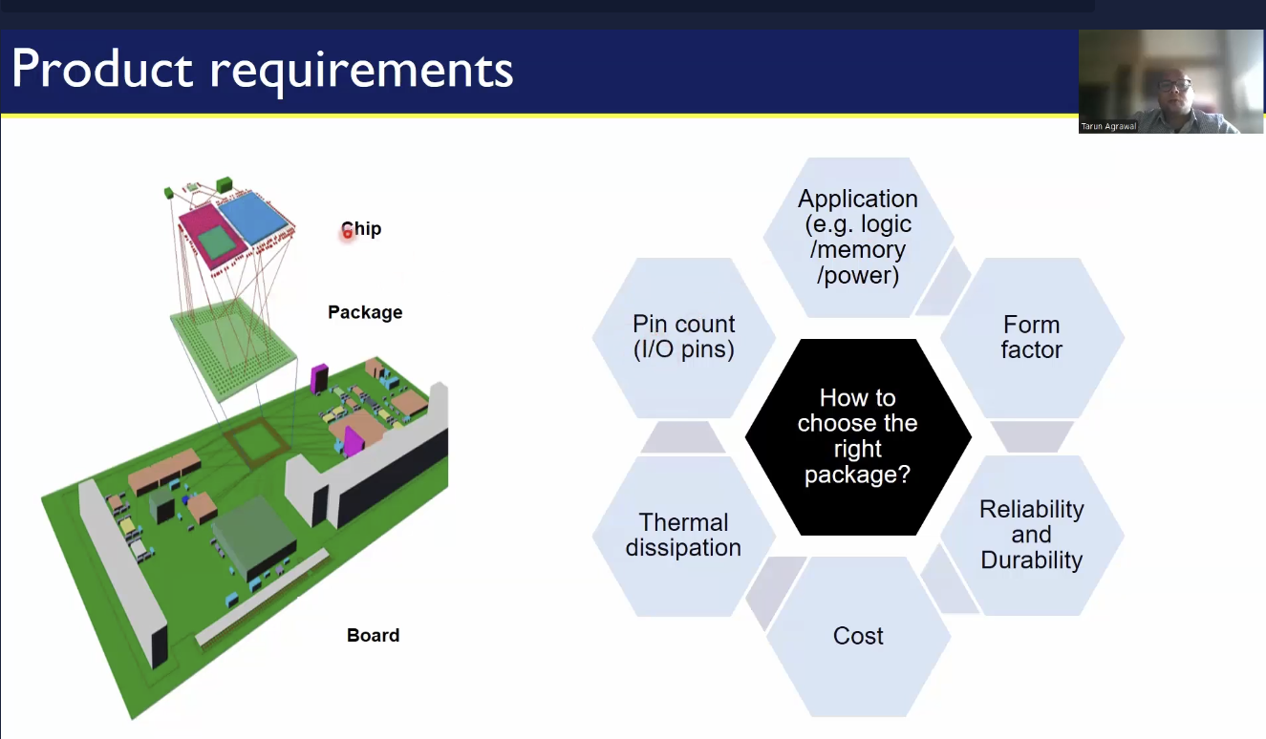

The chip is mounted on a package, which in turn is placed on the board. The key question is: how do we choose the right package?

One major factor is 🔌 electrical connectivity — the package must be capable of interfacing effectively with other packages on the board. If high-speed communication is required, sufficient pin count or interconnects must be supported to meet design needs.

Another critical aspect is 🌡️ thermal requirements. The package must manage heat efficiently. For instance, if the system is expected to operate at very high temperatures (e.g., above 200°C), standard laminate-based packages may not suffice; ceramic or other high thermal performance materials would be more appropriate. This makes the choice of substrate a crucial consideration.

Form factor also plays a role — the physical space available for the package on the board can influence the design.

Durability and long-term reliability 🔄 are equally important, both of which are heavily influenced by the materials used in the package.

And finally, perhaps the most important factor in any real-world design — cost 💲. The selected package must strike the right balance between performance, reliability, and budget.

### 🧱 Typical Package Structure

The image below illustrates the internal structure of a typical package and the connectivity.

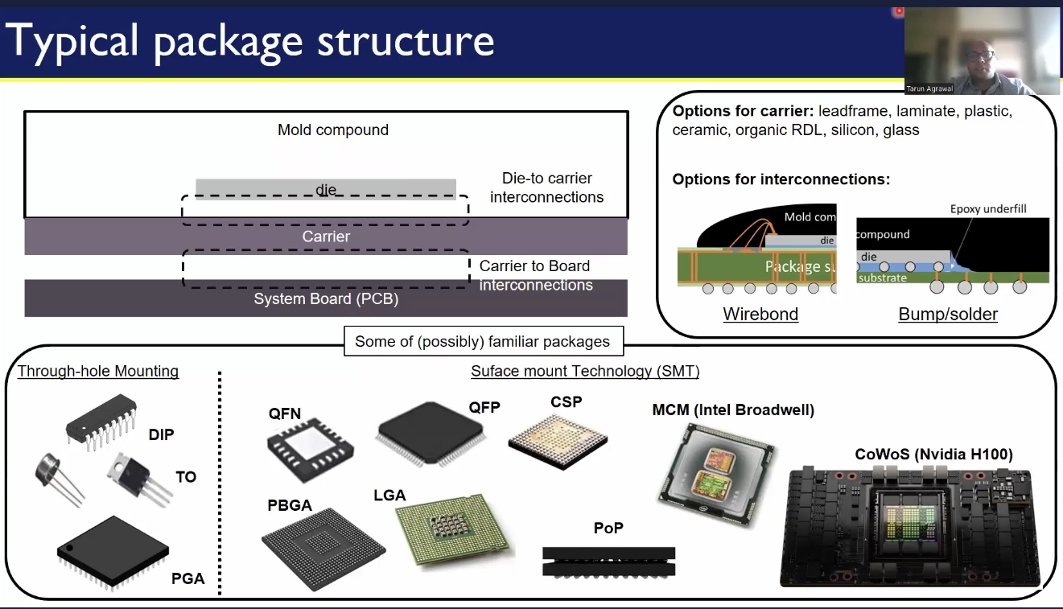

To understand the basic structure of a semiconductor package, let’s start with the die. The die is first mounted onto a substrate (or sometimes a carrier), establishing the initial connection through small bond wires or bumps. The substrate provides mechanical support, electrical connectivity, and thermal management. It can be made from materials like ceramic, organic laminates, or metal cores, depending on the application. Once the die is secured to the carrier, the next step is to connect the carrier to the PCB. Finally, a molding compound is applied around the assembly for protection. This material, often a type of epoxy or plastic, serves to protect the delicate components from environmental factors (e.g., moisture, dust) and mechanical stress.

There are two primary mounting technologies used in this process.

* Through-Hole Mounting (THM): one of the older methods, where the component leads (pins) pass through holes in the PCB and are soldered to pads on the opposite side. Holes are drilled into the PCB where the leads of the package will go. The leads of the component are inserted into these holes. The leads are soldered on the opposite side of the PCB, creating electrical connections.
* Surface Mount Technology (SMT): involves mounting electronic components directly onto the surface of a PCB, where the component leads are soldered to the surface-mounted pads (instead of being inserted through holes). This is done using automated machinery and solder paste.



## Evolving Package Architectures from Single-chip to Multi-chip modules

### 📦 Anatomy of Packages

Understanding the anatomy of a semiconductor package is essential for evaluating its performance in terms of electrical connectivity, thermal behavior, mechanical durability, and manufacturability. The specific implementation of each element can vary depending on package type, application, and design constraints, but the fundamental structure remains consistent across most modern packages.

#### Leadframe-Based Packages

A leadframe is a thin sheet of metal (typically copper or copper alloy) stamped or etched to form:  
- Die pad: A central area where the silicon die is mounted.  
- Leads: Metal fingers extending outward that serve as electrical paths from the die to the external PCB.

⚙️ Basic Structure of a Leadframe Package  
1. Silicon Die: Placed on the die pad of the leadframe.  
2. Die Attach: The die is attached to the pad using adhesive or solder.  
3. Wire Bonds: Gold or copper wires connect the die’s bond pads to the leads of the frame.  
4. Encapsulation: The assembly is molded in epoxy resin to protect the internal elements.  
5. Leads: The outer portion of the metal frame extends beyond the molding compound to allow surface mounting or through-hole soldering.

📦 Common Leadframe-Based Package Types  
DIP (Dual In-line Package) Rectangular body with two rows of through-hole leads. Used in older devices and through-hole boards.  
SOP (Small Outline Package) Surface-mount version of DIP with shorter, gull-wing leads.  
SSOP / TSSOP (Shrink/Thin SOP) More compact versions of SOP for higher pin density.  
QFP (Quad Flat Package) Four-sided surface-mount package with fine-pitch leads on all sides.  
LQFP (Low-profile QFP) Thinner version of QFP for compact applications.  
QFN (Quad Flat No-lead) Exposed pad package without leads; pads are on the bottom for better thermal and electrical performance.  
DFN (Dual Flat No-lead) Like QFN but with pads only on two sides. Very compact.

✅ Advantages of Leadframe Packages  
- Cost-Effective: Simple to manufacture, suitable for high-volume production.  
- Mature Technology: Well-established, with proven reliability.  
- Good Electrical Performance: Low parasitic inductance for many applications.  
- Scalable: Available in a wide range of pin counts and sizes.  
- Thermal Options: Versions like QFN with exposed thermal pads provide better heat dissipation.

❌ Limitations  
- Limited I/O Density: Compared to advanced packaging (e.g., BGA or flip-chip).  
- Thermal and Electrical Performance: May not meet requirements for very high-performance systems.  
- Size: Leaded versions (like DIP and SOP) can be bulky compared to modern alternatives.

💡 Applications of Leadframe Packages  
- Consumer electronics  
- Automotive electronics  
- Power management ICs  
- Microcontrollers (MCUs)  
- Analog/mixed-signal ICs  
- LED packages

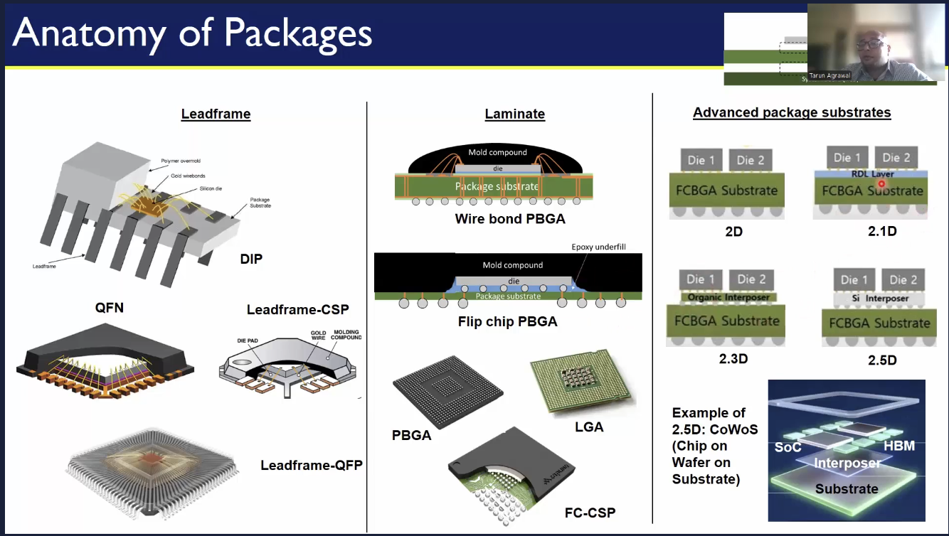

#### Laminate-Based Packages

A laminate-based package uses a multi-layer organic substrate (similar to a mini PCB) instead of a metal leadframe to support the die and route electrical signals. These packages enable high I/O density, fine pitch, and multilayer routing, making them ideal for advanced applications like processors, memory, and high-speed interfaces.

📦 Common Laminate-Based Package Types  
Wire Bond PBGA (Plastic Ball Grid Array) Die is connected via wirebonds to a laminated substrate with solder balls for board attachment.  
Flip Chip PBGA Die is flipped and directly bonded to the substrate using solder bumps, improving performance and reducing parasitics.  
LGA (Land Grid Array) No solder balls; flat contacts for direct PCB connection.

✅ Advantages of Laminate Packages  
- High I/O Density: Supports fine pitch and many interconnects.  
- Multilayer Routing: Embedded traces and vias allow complex signal routing.  
- Better Electrical Performance: Lower parasitics compared to leadframes.  
-Compact Form Factor: Smaller footprint with surface-mount capabilities.  
-Good Thermal Paths: Can include thermal vias or spreaders.

❌ Challenges / Limitations  
- More Expensive: Higher material and fabrication cost than leadframe packages.  
- Sensitive to Moisture: Requires careful handling and moisture control (MSL).  
- Complex Assembly: Requires precise alignment and reflow soldering.

💡 Applications  
- Microprocessors and high-speed ASICs  
- DRAM and Flash memory  
- Networking and telecom ICs  
- High-performance FPGAs  
- Mobile and consumer electronics



#### Advanced package substrates

Advanced substrates are high-performance materials and structures used in semiconductor packaging to support high I/O count, high-speed signal integrity, power delivery, and thermal management — especially in cutting-edge devices like processors, FPGAs, GPUs, and AI accelerators. Unlike traditional laminate or leadframe substrates, advanced substrates are engineered with fine line/space, multi-layer interconnects, embedded passives, and CTE-matched materials to support modern system demands.

* 2D: Multiple dies placed side by side on a single substrate (FCBGA). FCBGA (Flip-Chip Ball Grid Array) is a high-performance semiconductor packaging technology that combines the benefits of flip-chip die attach with a laminate substrate and ball grid array for board-level connections.
* 2.1D: Similar to 2D but includes an RDL (Redistribution Layer) to improve routing and integration.
* 2.3D: Uses an organic interposer to connect dies.
* 2.5D: Uses a silicon interposer for high-speed interconnects between dies, such as in CoWoS (Chip-on-Wafer-on-Substrate). 📌 Example: CoWoS (2.5D) TSMC CoWoS (Chip on Wafer on Substrate) integrates a silicon interposer with high-bandwidth memory (HBM) and a logic SoC on a common substrate. This design supports advanced applications such as AI and HPC (High-Performance Computing).



## Interposers Redistribution layers and 3D Packaging Approaches

### 1. Redistribution Layers (RDL)

🔍 What is RDL?  
RDL (Redistribution Layer) is a metal layer added on top of a die or wafer to reroute the I/O pads to new locations. This enables more flexible bump layouts, especially important for fan-out packages or wafer-level chip scale packaging (WLCSP).

💡 Applications  
- Fan-out wafer-level packaging (FO-WLP, FO-BGA)  
- Panel-level packaging (PLP)  
- Multi-die integration  
- System-in-Package (SiP)

✅ Advantages:  
- Allows larger bump pitch for finer pad layouts  
- Reduces package size and thickness  
- Enables multi-chip placement and interconnect on a single substrate

### 2. Interposers

🔍 What is an Interposer?  
An interposer is a passive or active layer inserted between the die and the substrate, acting as an intermediate routing interface. It enables dense signal routing, power delivery, and die-to-die interconnect.

Types: Silicon, Organic, Glass

✅ Functions:  
- Routes signals between multiple dies (e.g., chiplets)  
- Provides thermal expansion management  
- Enables high bandwidth communication

🧠 Passive vs. Active Interposers:  
- Passive: No logic, just routing and vias  
- Active: Includes power delivery, clocking, or even memory logic

### 3. 2.5D/3D Integration

* 2.5D: Multiple dies (e.g., CPU + HBM) placed side-by-side on a common interposer. Interposer provides connectivity, not the substrate directly. Popular in HPC and AI (e.g., AMD Instinct, NVIDIA GPUs with HBM).
* 3D: Dies are stacked vertically, interconnected through Through-Silicon Vias (TSVs). 3D NAND, HBM memory stacks, logic-on-logic stacking.

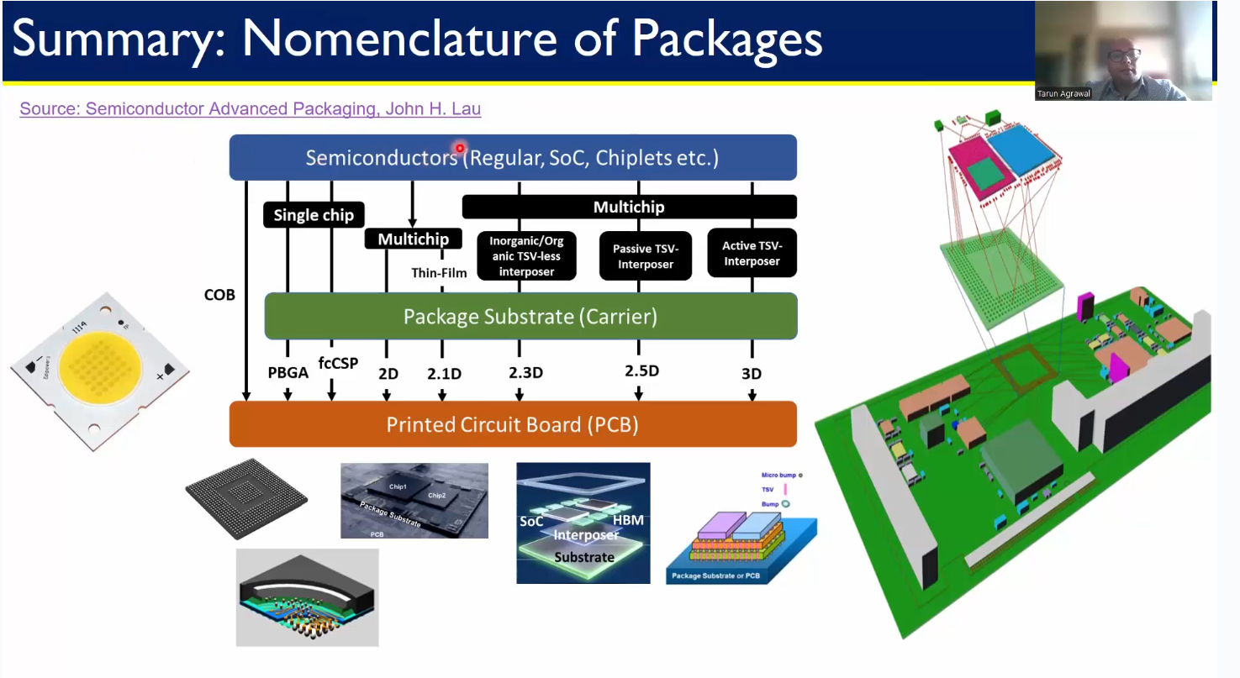

### 🧾 Comparison Tabl

## Comparative Analysis and Selecting the right Packaging Solution

Below is a clean, structured comparative Analysis of packaging technologies, followed by a guideline to selecting the right packaging solution.

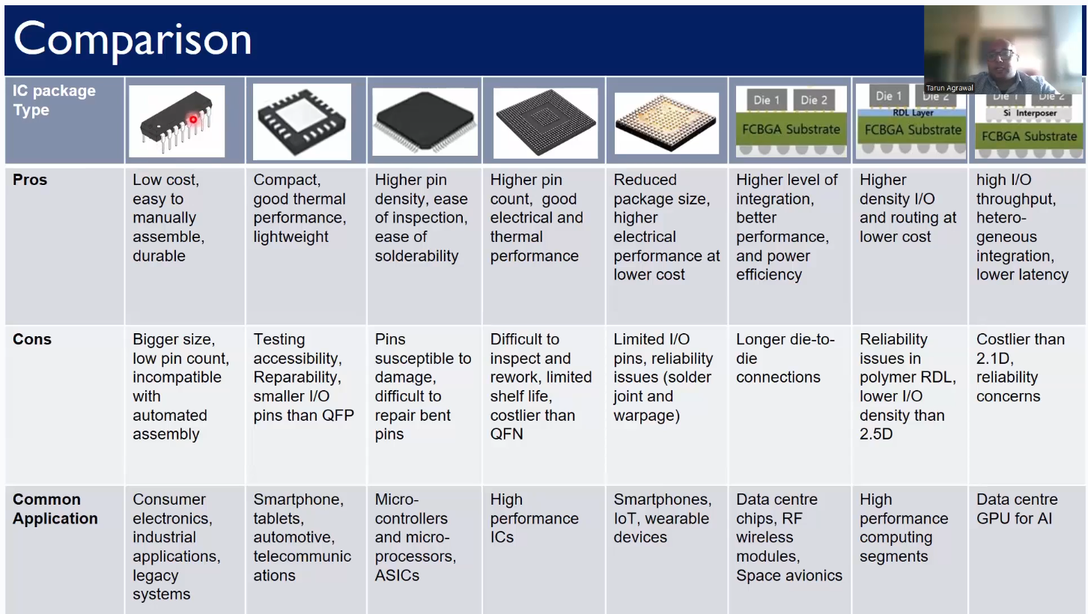

Choosing the right semiconductor packaging depends on multiple factors across performance, reliability, form factor, and cost. Below is a structured approach:  
🛠️ 1. Define System Requirements - like I/o count, die size, speed, bandwidth, thermal load etc.  
🧪 2. Match with Package Capabilities - needs like low cost, high performance compute, high bandwidth memory, space constraints etc.  
💡 3. Consider Cost vs. Performance Trade-offs - If cost is the primary driver, leadframe-based packages such as QFN or SOP, or standard BGA options, offer a cost-effective solution. For applications where performance is critical, advanced options like FCBGA, RDL-based packaging, or interposer-enabled designs are more suitable. In scenarios requiring ultra-compact form factors, fan-out wafer-level packaging (WLP) or 3D TSV-based packages provide optimal space efficiency. Lastly, for designs targeting future scalability, such as chiplet architectures or modular systems, 2.5D and 3D packaging approaches are ideal due to their flexibility and high integration capability  
🔍 4. Evaluate Manufacturing and Supply Chain Constraints - Substrate availability, ensuring compatibility with existing assembly and test processes, strong ecosystem support from suppliers, including OSATs (Outsourced Semiconductor Assembly and Test providers), substrate manufacturers, and foundry packaging services

## From Wafer to Package: Assembly and Manufacturing Essentials

## Setting the Stage: Supply Chain and Facilities

This section explains the semiconductor supply chain and provides a detailed look into a package manufacturing unit (ATMP – Assembly, Testing, Marking, and Packaging).

### 🔄 Review of the Supply Chain

The semiconductor supply chain is a complex, globally distributed network that spans design, manufacturing, assembly, testing, and distribution. Each stage involves highly specialized players and technologies, requiring precise coordination to deliver cutting-edge chips efficiently and reliably.

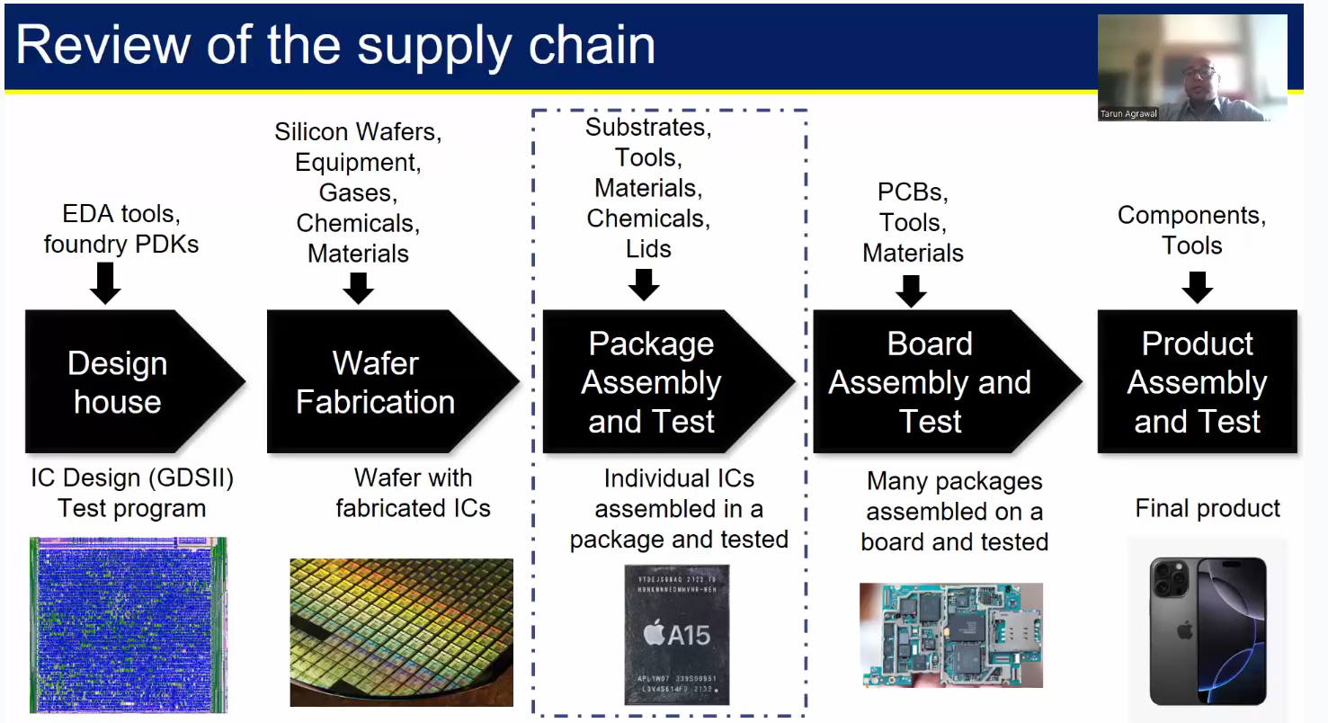

🧠 1. Design & IP Development

* Input: Product requirements, EDA tools, IP blocks, market specs
* Process: Architecture definition, RTL coding, synthesis, APR, verification
* Output: GDSII layout file (design tape-out). The GDSII file is sent to the foundry for mask creation and wafer fabrication.
* Who: Fabless companies (e.g., AMD, NVIDIA), EDA vendors (Synopsys, Cadence)

🏭 2. Wafer Fabrication (Foundry)

* Input: GDSII layout, silicon wafers, photoresist, gases, chemicals, masks
* Process: Photolithography, etching, deposition, ion implantation
* Output: Processed wafers with patterned dies
* Who: TSMC, Samsung Foundry, Intel, GlobalFoundries

📦 3. Packaging & Substrate Preparation

* Input: Singulated dies, substrate materials (e.g., ABF, BT resin), solder bumps
* Process: Die attach, wire bonding or flip-chip, molding, RDL/interposer integration
* Output: Packaged IC (e.g., BGA, QFN, FCBGA, 2.5D/3D)
* Who: ASE, Amkor, JCET, Shinko, Ibiden

🧪 4. Assembly & Test (OSAT)

* Input: Packaged ICs, test programs, ATE systems
* Process: Functional and parametric testing, burn-in, sorting
* Output: Qualified ICs, binned by performance. Yield improvement and binning are critical for profitability.
* Who: ASE, Powertech, Amkor, UTAC

📱 5. System Integration & Distribution

* Input: Packaged, tested ICs; PCBs; passive components
* Process: SMT assembly, system-level integration, validation
* Output: Complete electronic systems (e.g., smartphones, servers)
* Who: OEMs Original Equipment Manufacturer (Apple, Cisco), ODMs Original Design Manufacturer (Foxconn, Pegatron), EMS Electronics Manufacturing Services (Flex, Jabil)  
  Example  
  ➡️ OEM (Apple)  
  ➡️ contracts ODM (Quanta) to design hardware  
  ➡️ who works with EMS (Foxconn) to mass-produce and assemble the final product.

### Introduction to a Package Manufacturing Unit (ATMP)

The ATMP process involves four core activities: Assembly, Testing, Marking, and Packaging.

🏭 Where is ATMP Performed?

Major ATMP Hubs:

* ASEAN region: Malaysia, Vietnam, Thailand, Philippines
* East Asia: Taiwan, China, South Korea
* Rising hubs: India, Mexico

Key Players:

* OSATs (Outsourced Semiconductor Assembly & Test): ASE, Amkor, JCET, UTAC
* IDMs with in-house ATMP: Intel, Samsung, Micron

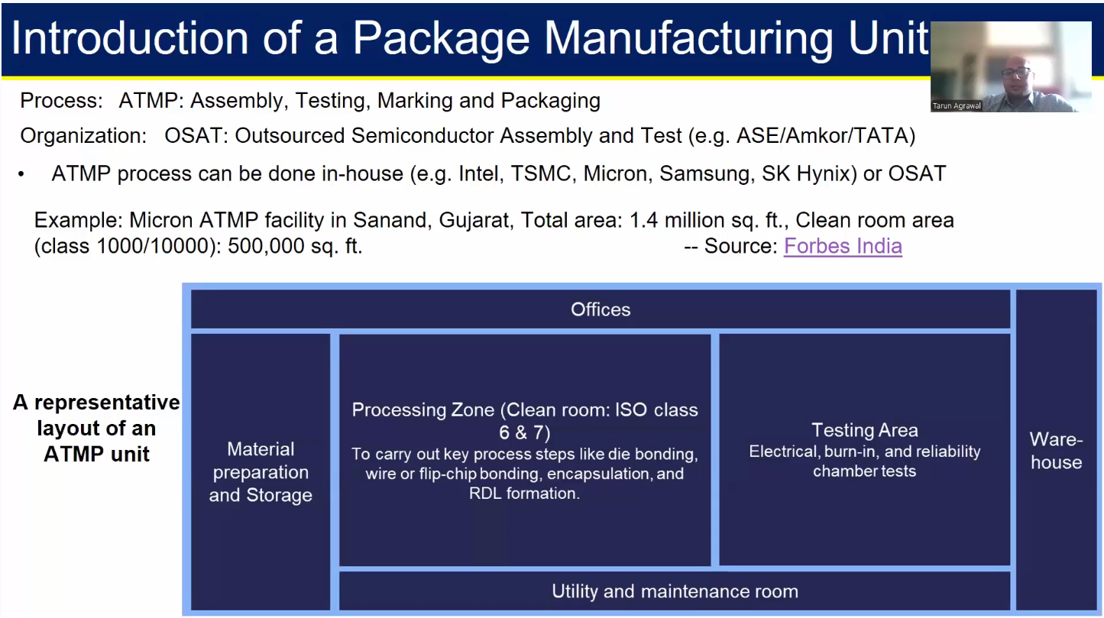

Layout of an ATMP unit:

* Admin/Office: Design Review, Data Management, QA/Engineering Lab
* Materials receiving/Warehouse: Incoming Wafers; Substrates, Leadframes, Mold Compounds, Consumables
* Cleanroom/Production Area: Die Preparation, Die Attach & Mount, Wire Bonding / Flip-Chip Bonding, Encapsulation / Molding, Final Assembly & Finishing
* Test area: Electrical test, Burn-in test, Functional test, Yield analysis
* Marking/Laser Engrave: Final inspection, QA
* Packaging/Labeling: Shippong & outbound logistics

## Wafer pre-preparation: Grinding and Dicing

This section outlines the sequence of steps involved in the wafer preparation process inside an ISO Class 7 cleanroom of an ATMP (Assembly, Testing, Marking, and Packaging) facility. Cleanrooms are essential for maintaining strict control over dust, particles, temperature, humidity, and electrostatic discharge, especially during sensitive semiconductor assembly steps.

### 🧼 Activities Inside the Cleanroom (Class 1000–10000)

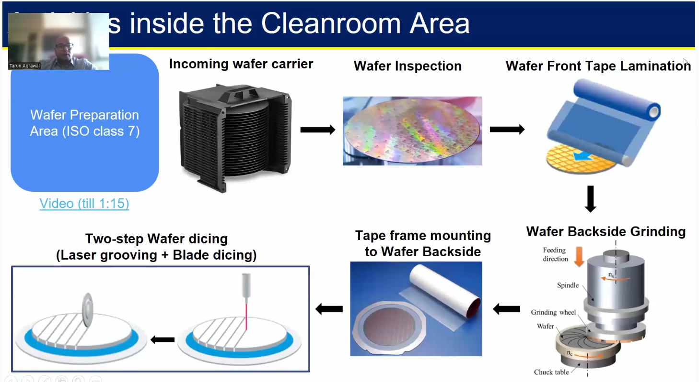

Wafers enter the cleanroom in protective carriers to avoid contamination. Before packaging, the wafers—typically 12-inch and around 700–800 microns thick—must be thinned since only the front side contains circuitry, while the backside is structural. The process begins with wafer inspection and testing, followed by front-side protection using lamination. The wafer is then flipped and back grinding is performed to reduce thickness, which introduces mechanical stress and must be carefully managed to avoid breakage. After grinding, a tape frame is applied to the wafer, and dicing is done using either blade or laser methods (laser preferred). The individual chips are then ready for packaging.

[A Look Inside - Amkor Manufacturing](https://youtu.be/hR5orrmpoeE?si=HSSnPypsR-nuPQGj)

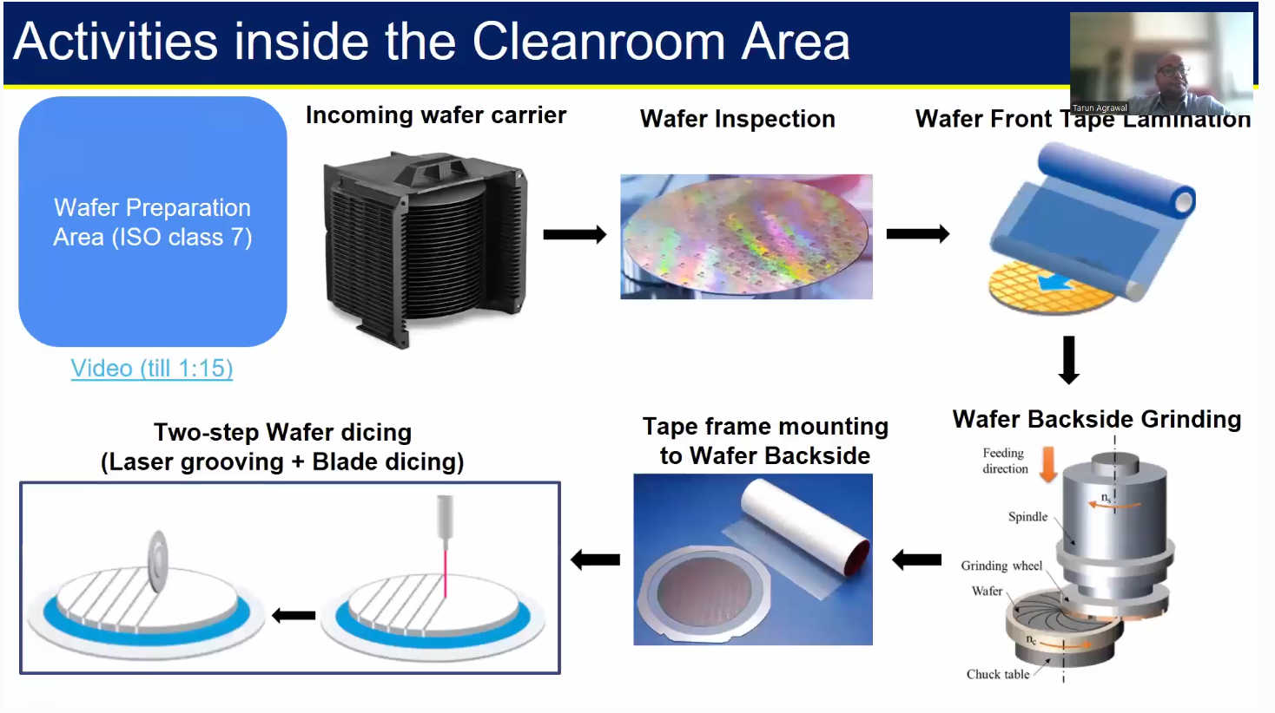

## Wire Bond Packaging: Die attach to Molding

Wire bonding is a method used to create electrical connections between the silicon die and the package leads or substrate using fine metal wires. It is a mature, cost-effective, and reliable technology, widely used in a variety of packages including QFN, SOP, and even some BGA formats.

[HB100 Automatic Wire Bonder - Bond Modes](https://youtu.be/3YkGrhvrWxA?si=wZ3nww72NH6X6e4v)

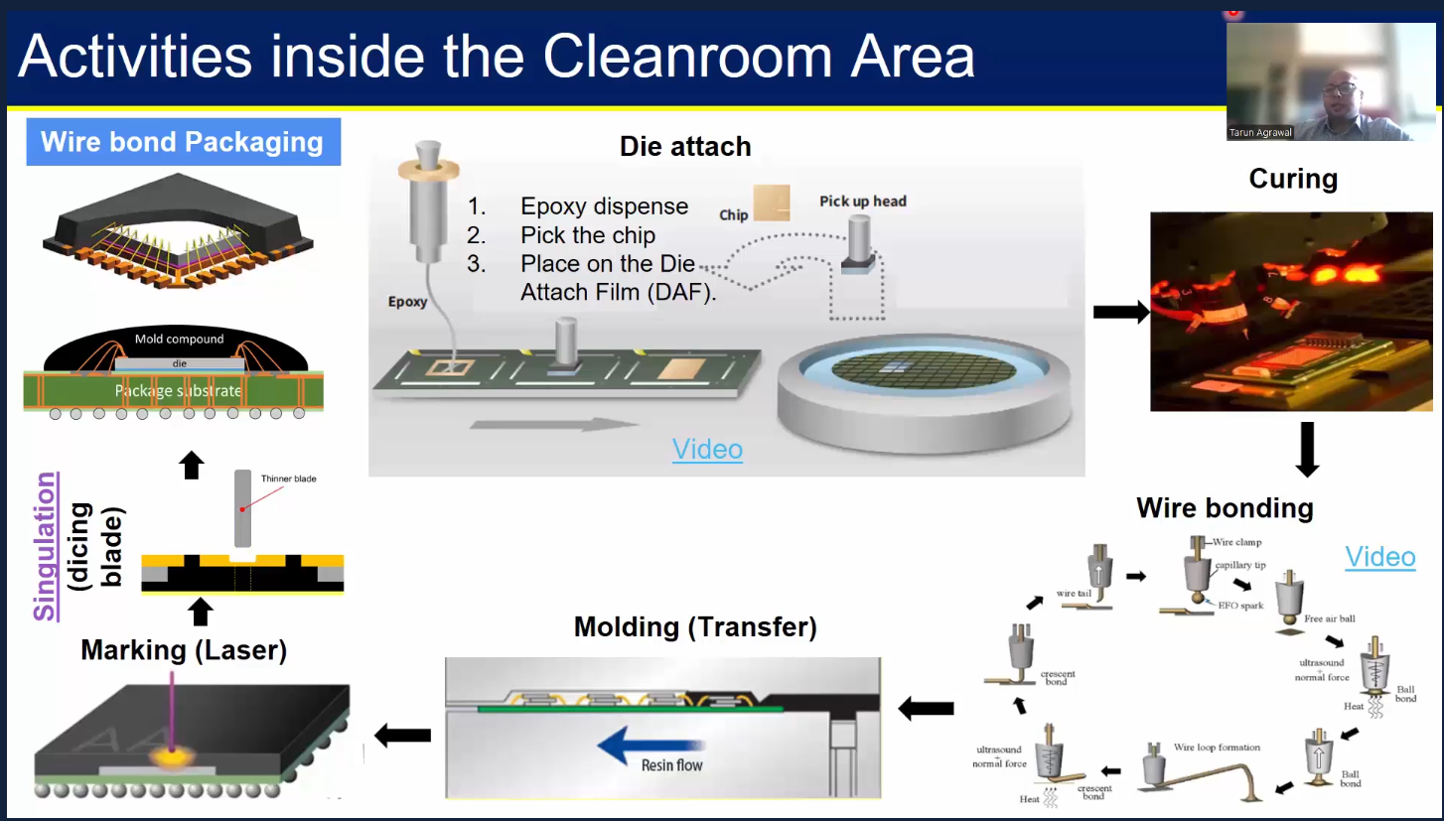

📦 Wire Bond Packaging Process – Step-by-Step

1. Start with a Diced Wafer  
   * The wafer has already been cut into individual dies (chips)
2. Die Selection & Placement (Die Attach)  
   * Select a good die from the wafer
   * Place the die onto a substrate (either laminate-based or leadframe)
3. Apply Die Attach Film or Epoxy  
   * Dispense adhesive (typically epoxy, acting like glue) onto the substrate
   * The die is then placed onto the adhesive
4. Curing  
   * Cure the epoxy to secure the die and relieve mechanical stress
   * Curing is done using thermal ovens or UV light
5. Wire Bonding  
   * Create electrical connections between the die and the substrate using fine metal wires (gold, copper, or aluminum)
   * Wire bonding acts like "flyovers" to bridge the die pads to package terminals
6. Molding / Encapsulation  
   * Encapsulate the die and wires with a plastic mold compound for mechanical protection
7. Marking  
   * Mark the package with identifying information (e.g., part number, lot code) for traceability
8. Singulation (Dicing)  
   * The final packaged units, typically processed in panels or arrays, are separated (singulated) using a dicing blade
   * This step cuts out the individual packages from the molded array

✅ Notes:

Wire bonding is a cost-effective and widely used packaging technique. It’s preferred in many applications due to its simplicity, flexibility, and low cost.

## Flip Chip Assembly: Bump Formation and Underfill

Flip Chip packaging is an advanced method of connecting the die to the substrate face-down, using solder bumps placed directly on the die’s I/O pads. Unlike wire bonding, which uses wires to make connections from the top of the die, flip chip offers shorter, more efficient interconnects, enabling higher performance and smaller form factors.

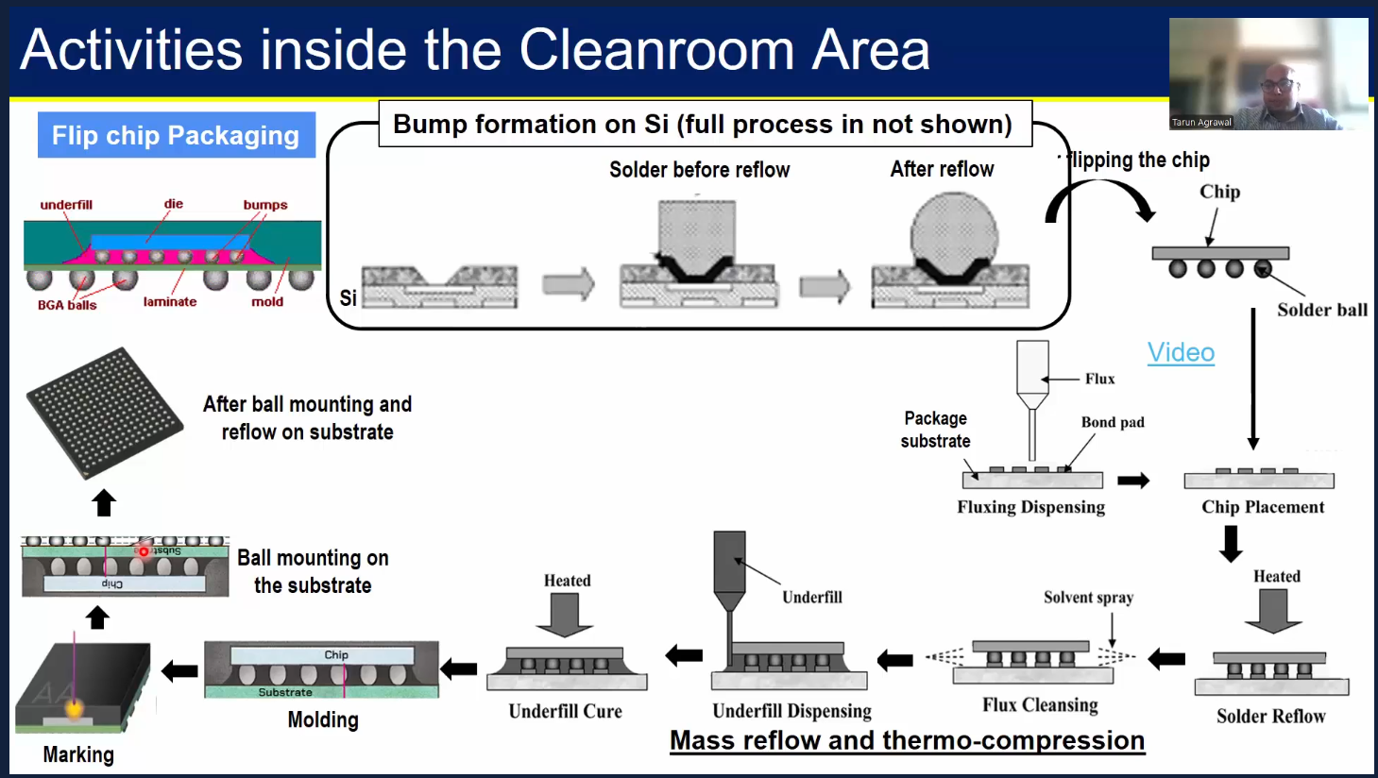

🔧 Flip Chip Packaging Process – Step-by-Step

1. Bump Formation  
   * Solder bumps (e.g., SnAgCu) or microbumps are formed on the die pads
   * Techniques include electroplating, solder paste printing, or stud bumping
2. Wafer-Level Testing & Dicing
   * The bumped wafer is tested and then diced into individual dies

Mass Reflow and Thermo-compression process

1. Die Placement (Flipping the chip)
   * The die is flipped face-down and aligned so the bumps face the substrate
   * It is placed directly on metal pads of the substrate or interposer, which already have some bond pad and flux. Flux is an environment to protect the metal from oxidation.
2. Solder reflow
   * The entire assembly is heated in a reflow oven
   * Solder bumps melt and solidify to form strong electrical and mechanical joints
   * The process is a mix of heat and pressure to connect the pads adequately
   * Reflow is a process important from reliability dtandpoint
3. Flux cleansing - remove the previously applied fill not need anymore.
4. Underfill Application
   * Primary job - to mitigate/reduce stress - CTE(coefficient of thermal expansion )
   * An underfill epoxy is dispensed between the die and substrate to enhance reliability
   * It prevents mechanical stress and improves thermal cycling performance
5. Underfill Cure - curing the underfill by heat to lock it in place
6. Molding / Encapsulation (if needed)
   * Some flip-chip packages are molded, especially for consumer and mobile applications
7. Marking and Ball mounting on the substrate
   * To connect to the outside world from the substrate (filp the package)
8. Final Testing and Singulation
   * The completed packages undergo electrical testing, X-ray inspection, and are then singulated if processed in panel format

## Wafer Level Packaging And Conclusion

Wafer-Level Packaging is a technique where the entire packaging process is done at the wafer level, before dicing. Unlike traditional methods that package individual dies after dicing, WLP processes all chips while still on the wafer, resulting in smaller size, lower cost, and higher performance. For mobile applications where we want the chip to be as small as possible

There are two main types:

* Fan-In WLP – Interconnects remain within the die footprint
* Fan-Out WLP (FOWLP) – Interconnects extend beyond the die, enabling more I/Os

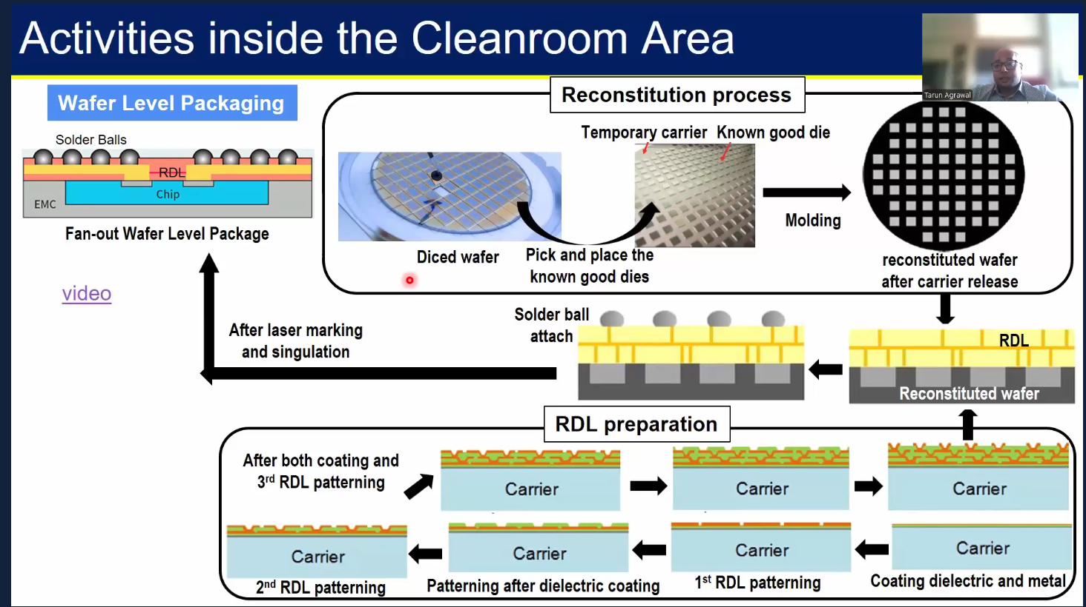

🔧 Wafer-Level Packaging Process – Step-by-Step [Reconstitution process

Dies places closed to each other   
📦 Fan-Out Wafer-Level Packaging (FOWLP) – Key Features & Process Highlights

1. Flip Chip Orientation
   * The die is placed face-down (flipped) and embedded in EMC (Epoxy Molding Compound)
2. No Traditional Package Substrate
   * Unlike conventional flip chip, no laminate substrate is used
3. Redistribution Layer (RDL)
   * An interconnecting metal layer (RDL) is built over the molded wafer
   * It reroutes the die’s I/O to external solder balls
4. Routing on RDL Instead of Laminate
   * In flip chip with laminate, routing is done via laminate vias
   * In FOWLP, all routing is handled by the RDL, adding design complexity
   * RDL similar to BEOL stack
5. Size Reduction Benefit
   * Despite the complexity, the absence of a substrate allows for a much smaller package footprint
6. Reconstitution Process  
   * Instead of attaching the die to a substrate, multiple dies are placed on a temporary carrier, close together
   * The entire array is molded to form a reconstituted wafer
7. Post-Mold RDL Formation  
   * After molding, RDL layers are fabricated on the flat surface to complete electrical connections
   * Initial dielectric and metal layers are deposited on the reconstituted wafer
   * Multiple RDL layers are patterned for interconnection routing
   * Solder balls are mounted on the final RDL pads to enable surface mounting
8. Carrier Removal & Dicing  
   * The carrier is removed, and the molded wafer is diced into packages

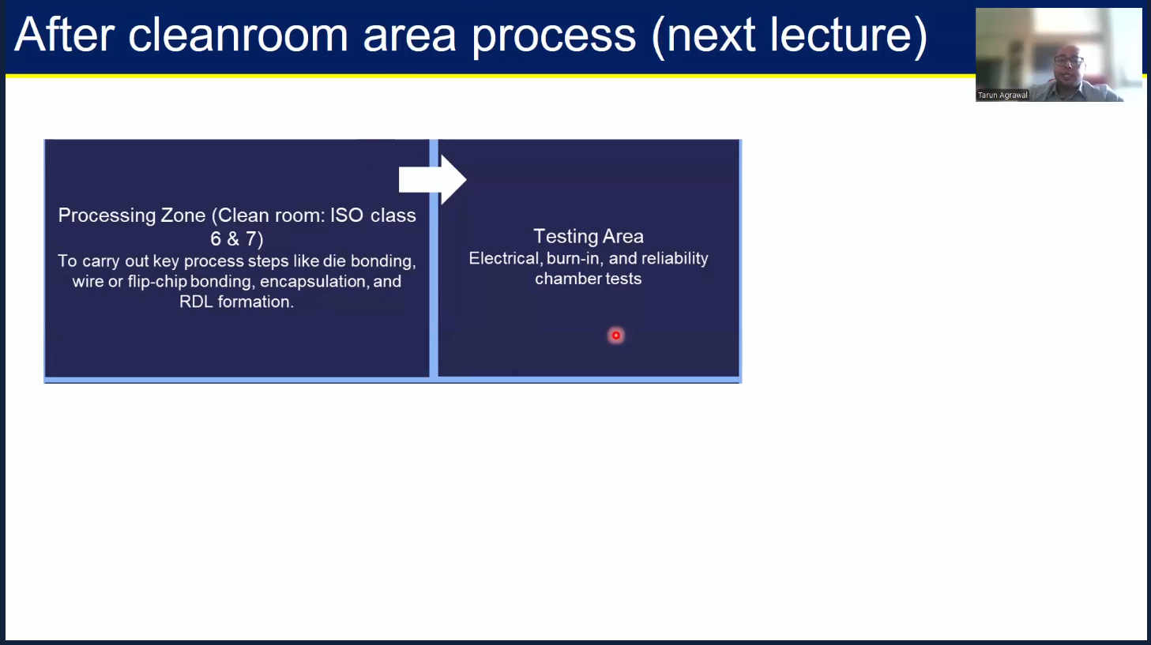

## Labs: Thermal Simulation of Semiconductor Packages with ANSYS

## Introduction And Getting Started With ANSYS Electronics Desktop

ANSYS Electronics Desktop (AEDT) is a unified platform that integrates multiple electromagnetic, circuit, and system simulation tools within a single GUI. It’s widely used for designing and analyzing high-speed electronics, including PCBs, IC packages, antennas, RF components, and power electronics.

🛠️ Key Features of ANSYS Electronics Desktop

1. Unified Environment  
   * Combines multiple solvers: HFSS, Maxwell, Q3D Extractor, Icepak, SIwave, and Circuit Designer.
   * Seamless project management with shared geometry, material libraries, and workflow automation.
2. Simulation Capabilities  
   * HFSS – Full-wave 3D EM simulation (antennas, packages, RFICs, connectors)
   * Maxwell – Low-frequency EM simulation (motors, transformers, inductors)
   * Q3D Extractor – Parasitic extraction of RLC values for interconnects
   * Icepak – Thermal and airflow simulation
   * SIwave – Signal and power integrity analysis for boards and packages
   * Circuit Designer – Circuit-level transient and harmonic analysis
3. Multiphysics Integration  
   * Electro-thermal, electro-mechanical, and EM-circuit co-simulation supported
   * Enables coupling between solvers for accurate, system-level predictions
4. 3D Layout and ECAD Integration  
   * Direct import from ECAD tools (e.g., Cadence, Mentor, Altium)
   * Full support for 3D layout-driven designs including stacked-die, flip chip, BGA, FOWLP
5. High-Performance Computing (HPC)  
   * Supports distributed, multi-threaded simulations for faster turnaround
   * Batch simulation, parameter sweeps, optimization loops
6. Automation and Scripting  
   = Built-in IronPython scripting support for custom workflows  
   Ansys ACT extensions to build custom apps and toolkits

**The tool used here is Icepak which is used to do thermal analysis of packages.**

**Tools -> Insert Icepak design**

**Desktop -> Icepack icon**

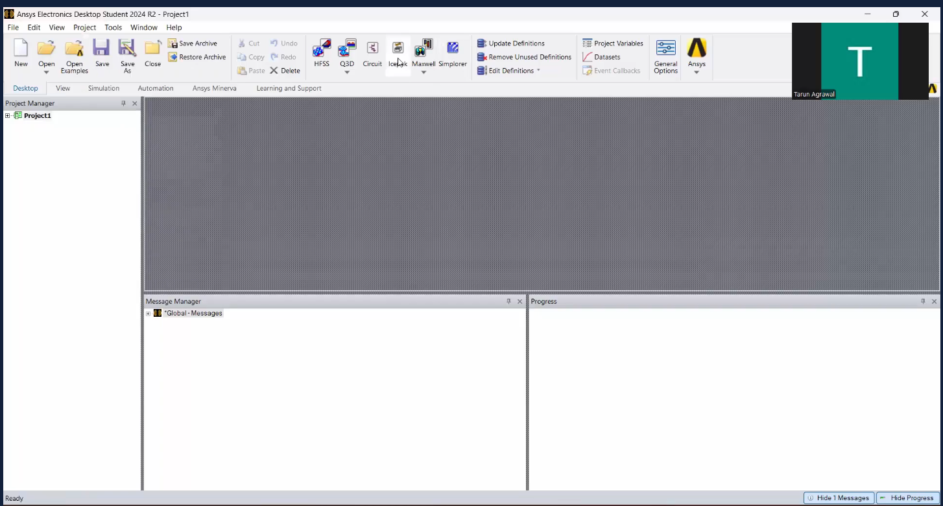

**Different WIndows -**

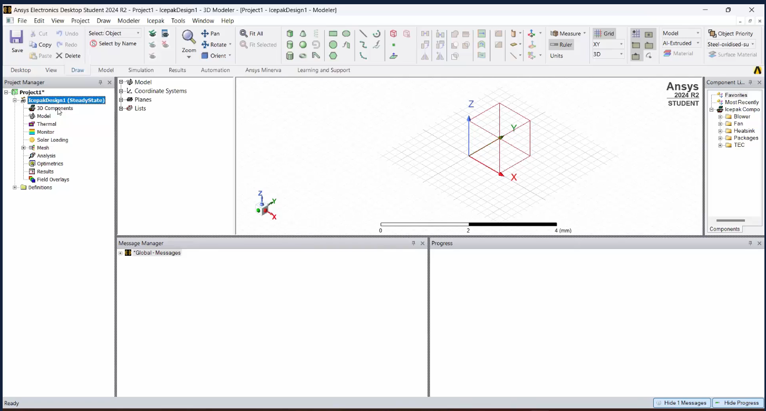

**Ice pack design elements**

1. **3D components - Structure component of the design**
2. **Boundary conditions - Thermal boundary conditions on the edges, Monitoring - edges and the points, Mesh - to solve finite element analysis, Analysis - solving the thermal equations, Results**

**Options available -   
Draw - draw different geometries**

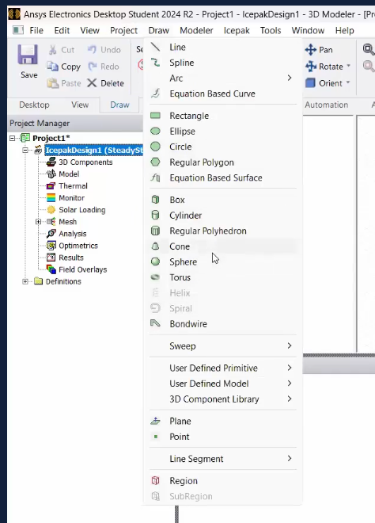

The idea is to analyse the different package/ components or settings of a package. So we are importing an already built-in package available in ANSYS.

Icepak -> Toolkit -> Geometry -> Packages -> Flichip_BGA

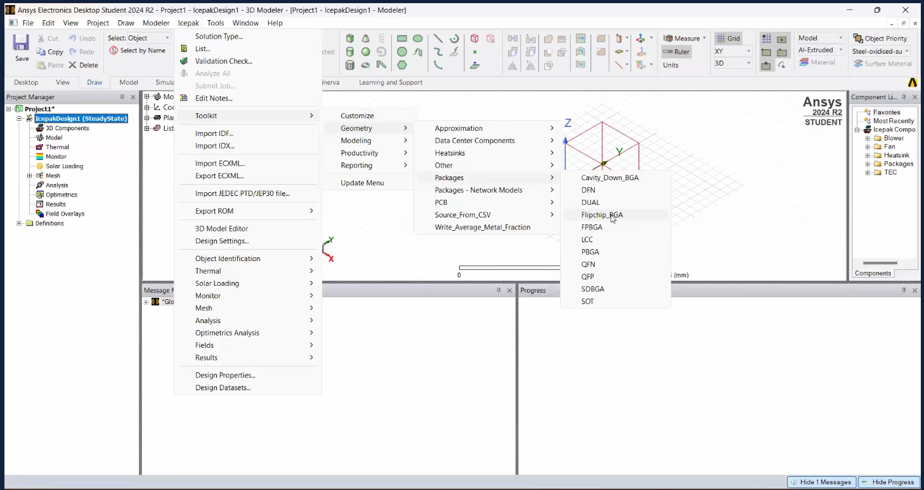

## **Setting Up A Flip-Chip BGA Package**

After clicking Fullchip_FPGA - popup opens to create package.

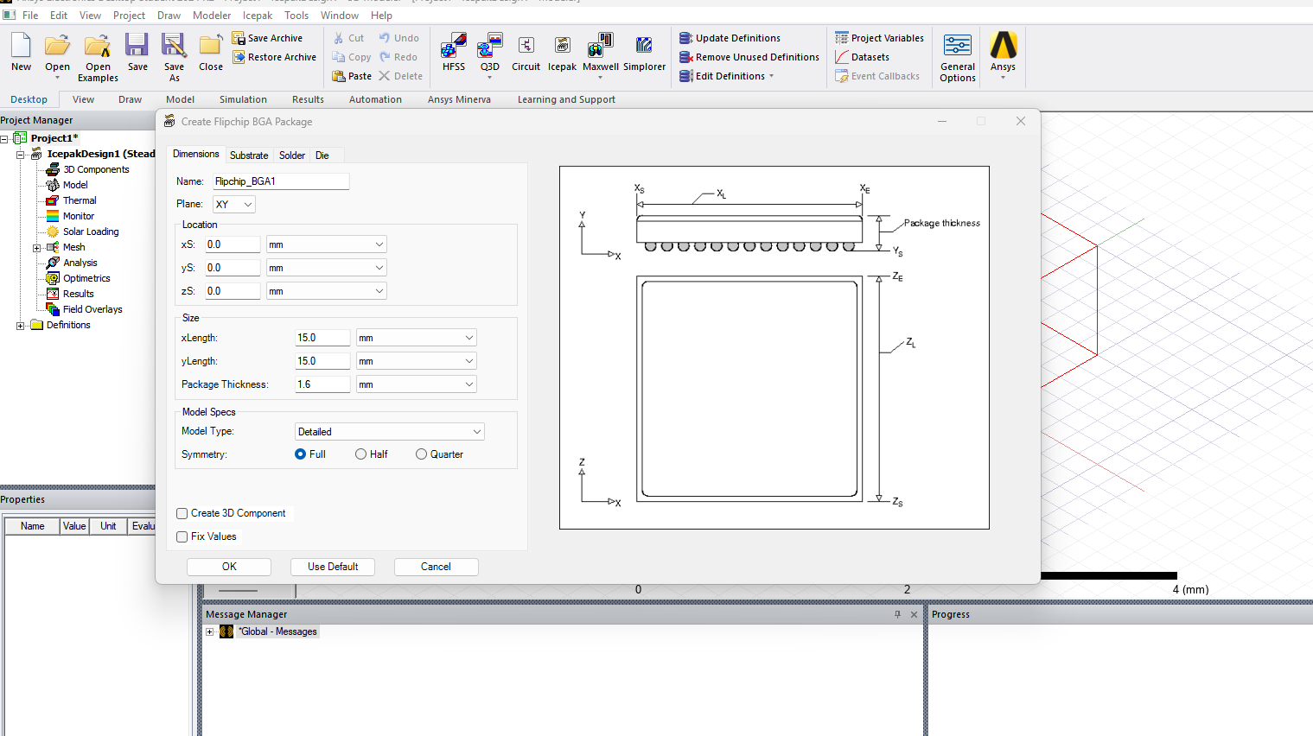

If interest - look up package datasheet - the dimensions are given, which is according to the die size to pack

Location - origin - XY plane - dimensions of the package. 2. Package thickness.

Typical package - 10mm-20mm

The package has a particular dimension. We are taking the default values for simulation.

The dimensions of the die is nearly half of that of the package dimensions as seen below.

Die Setup

* Package 15mm x15mm Die 8.56mm x8.56mm
* Power - 1W
* Material - Si-typical
* Die Underfill
  + Bump size 0.01 mm ~0.1cm
* Heatsink - typically over die. Add extra cost

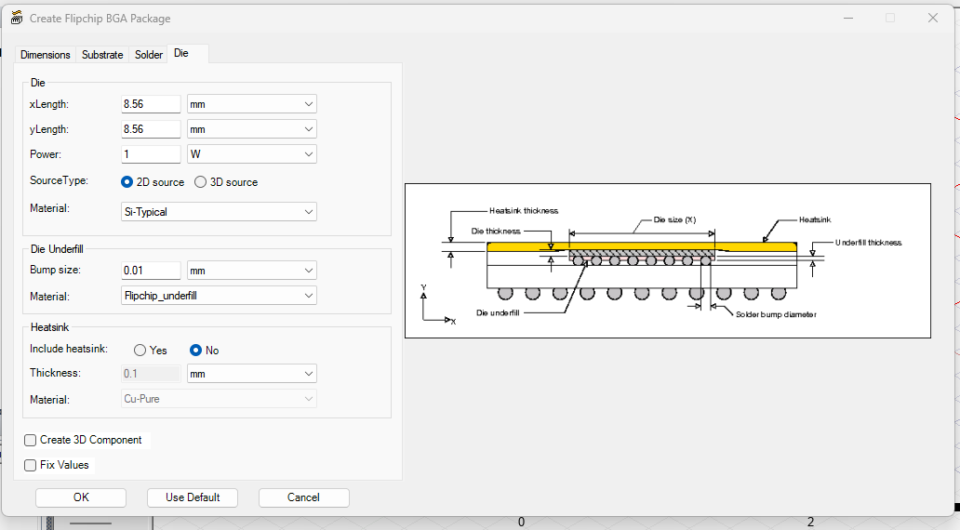

**Substrate Setup:**

Substrate -

* Number of Layers - 2 - defining intermediate layers.Top and Bottom by default
* Substrate Thickness - 0.36mm ~ ⅕ of the package thickness

Trace -

* Top Trace COverage % 55.0
* Trace material - Cu-pure

Vias

* Number of thermal vias - 0

One can check if the parameters are changed what is the full thermal effect map of the die.

Example - reduce via diameter , therefore number of vias (redundancy increases), better heat flow, therefore good thermal dissipation

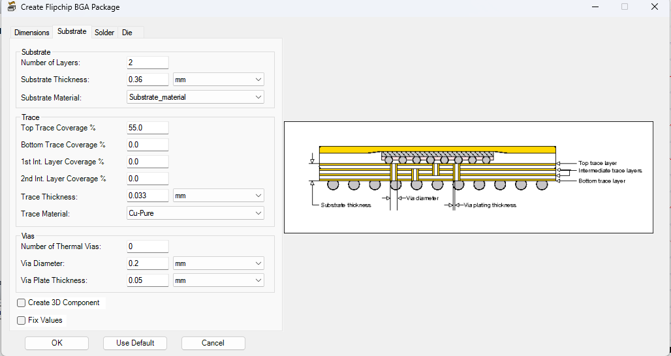

Solder setup:

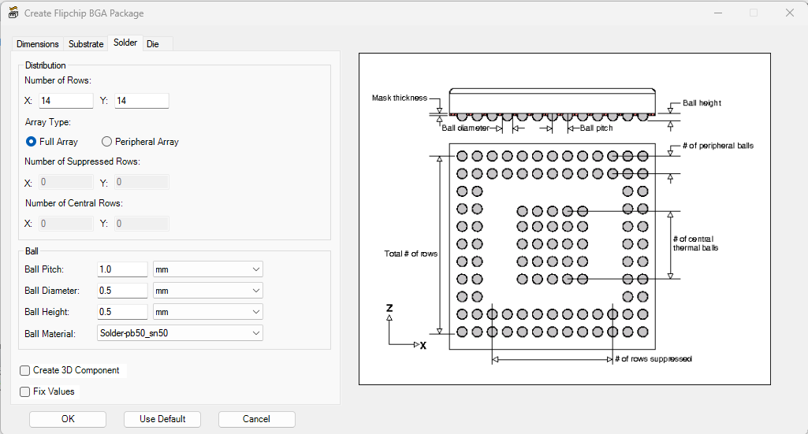

We are going to create the model using default dimensions. The model is going to be created as below.

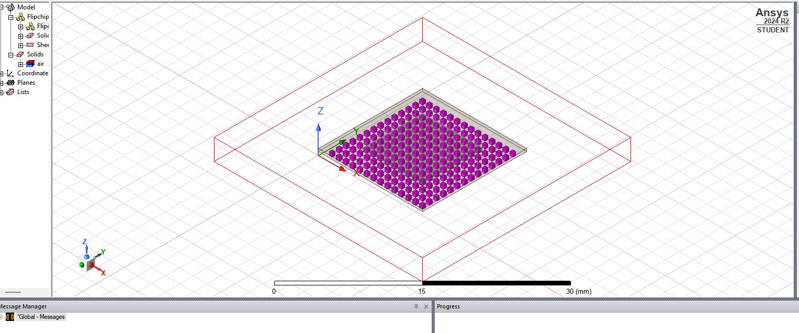

Top Model -

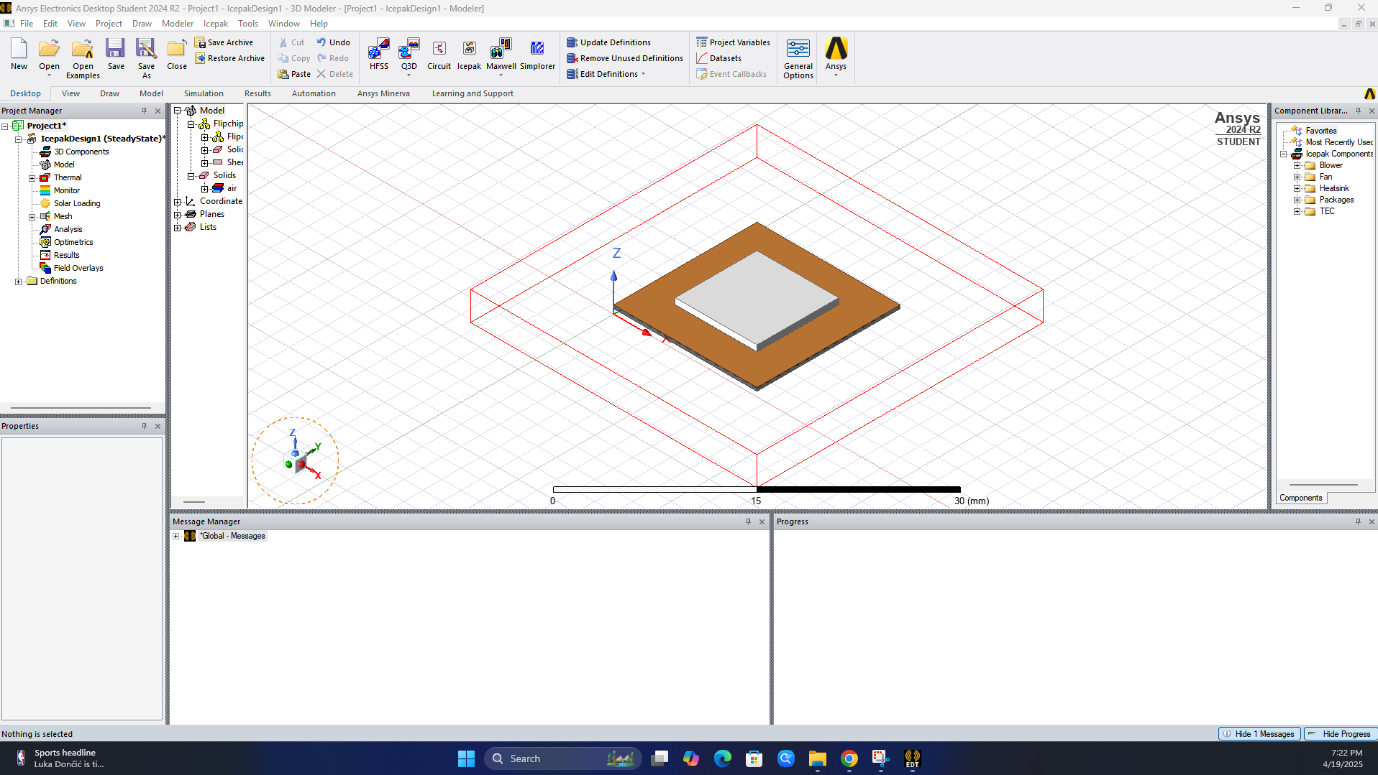

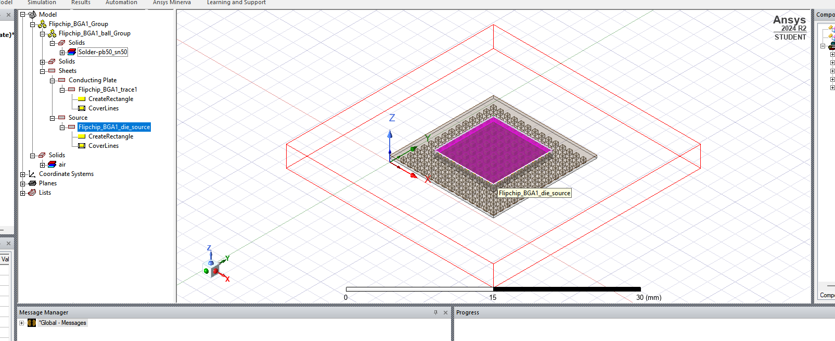

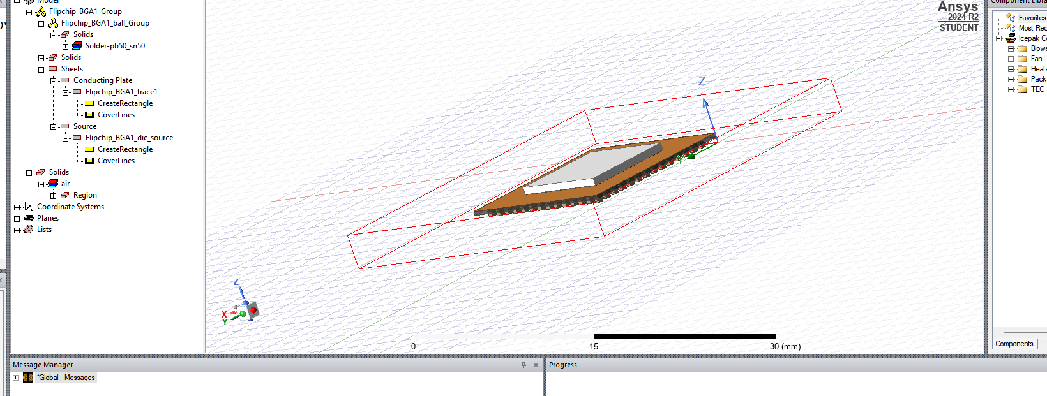

## Material Definitions And Thermal Power Sources

Double click on Model in left column for pop-up. Give Model definitions.

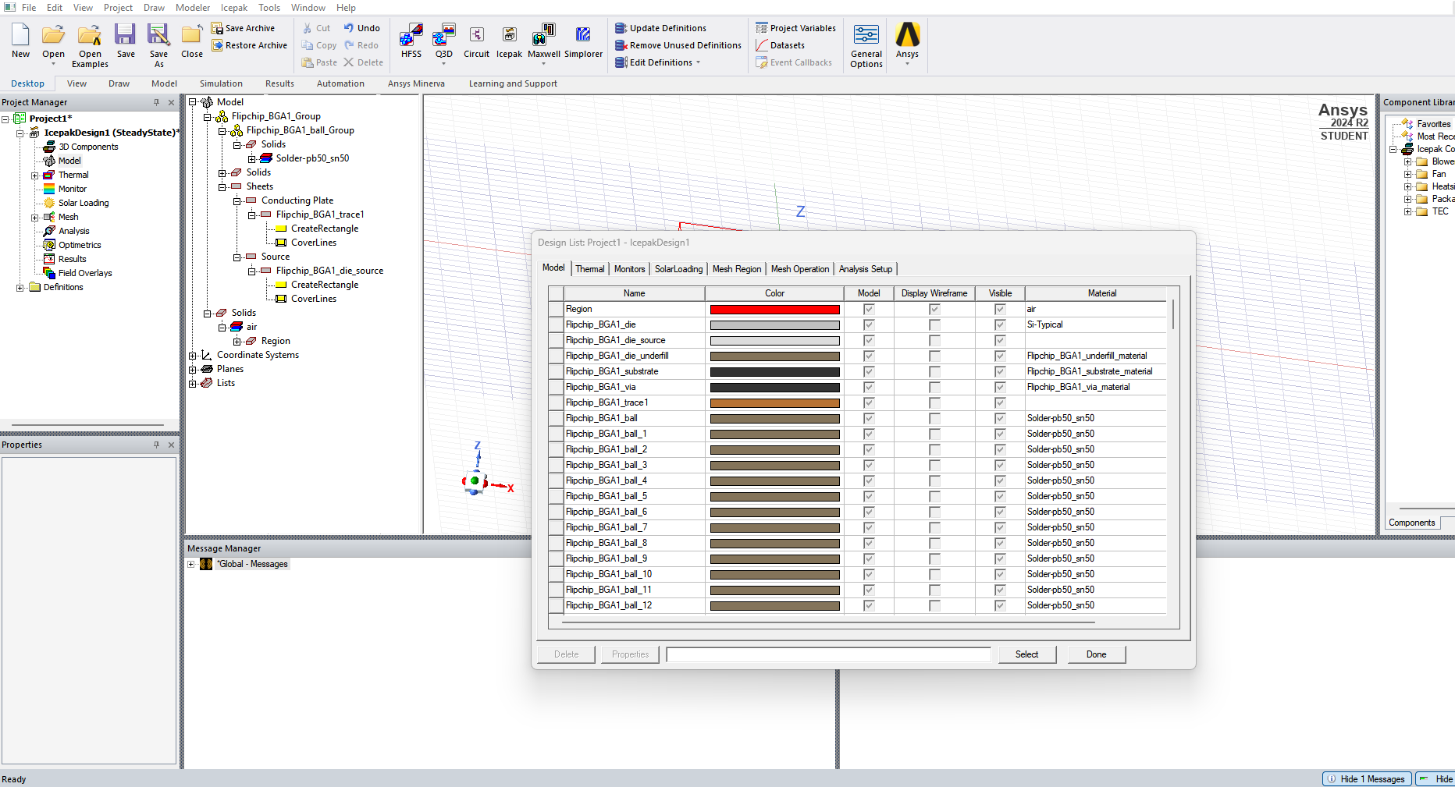

Thermal condition on the die source:

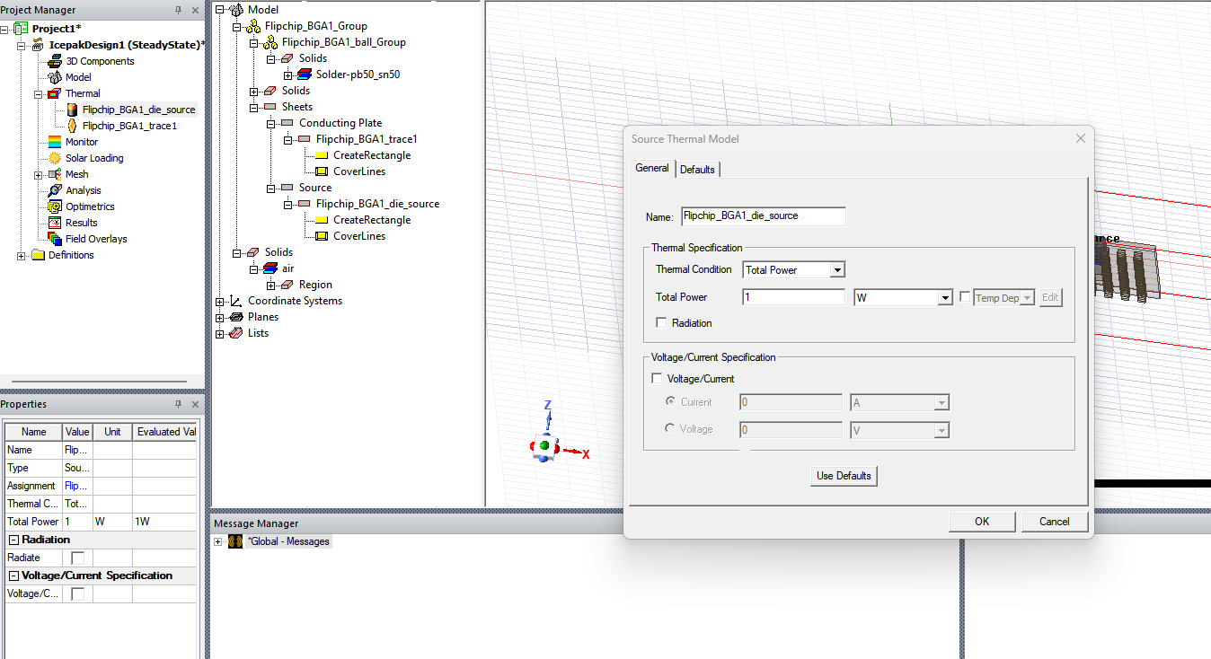

Thermal condition on the substrate:

Right click (Flipchip_BGA1_substrate) -> Assign Thermal -> Source

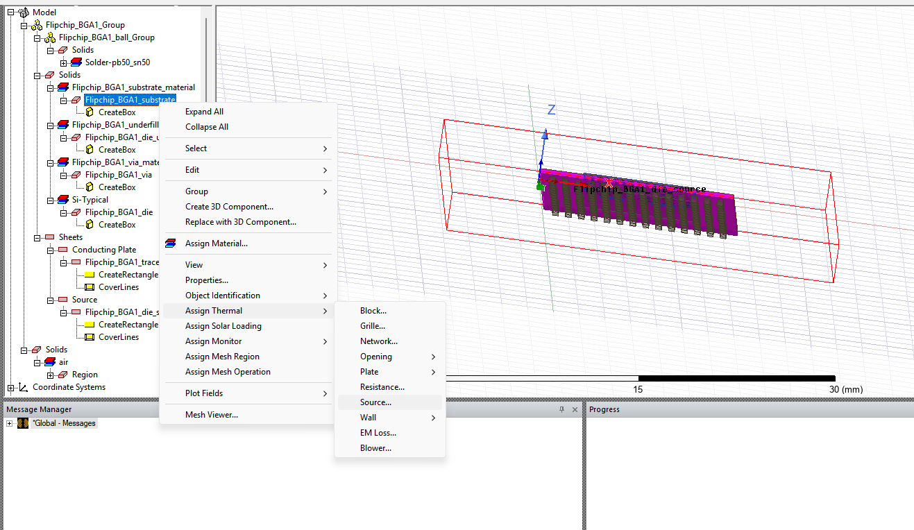

Select FIxed_temprature [ since Power is selected for the die]

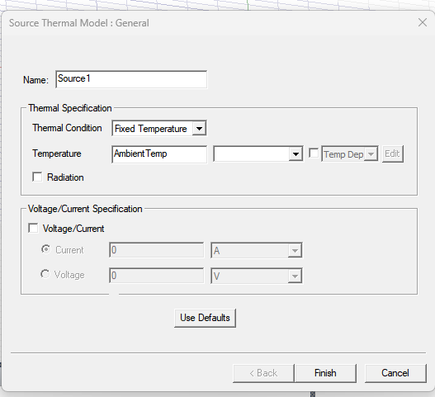

Warning for boundary source. Remove the boundary source

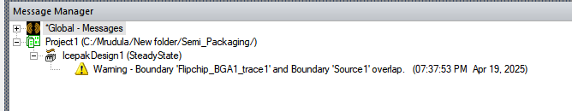

Right click to remove

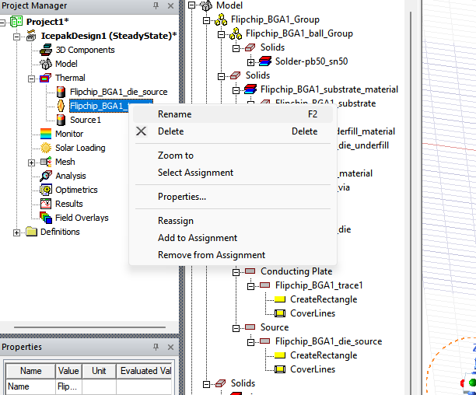

Monitor temperatures of die, underfill and substrate.

Substrate Point Monitor - Temperature

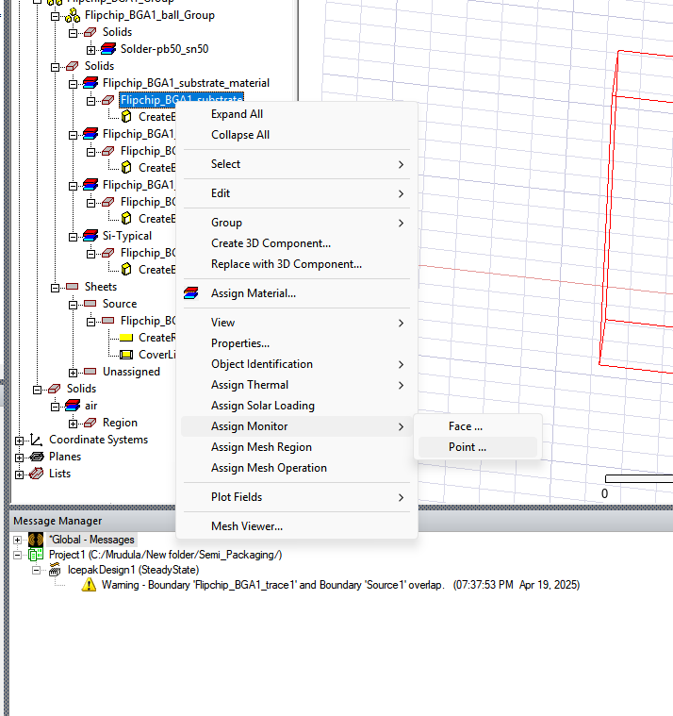

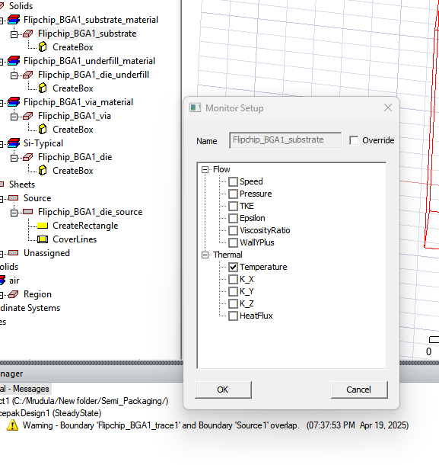

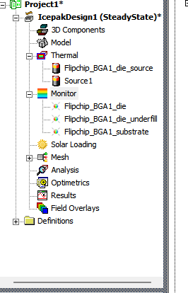

## 

## Meshing And Running The Thermal Analysis

Mesh visualization shows the number of elements generated. Quality can also be analysed. For accurate simulation, mesh quality is very important.

Mesh -> SImulation -> Generate Mesh

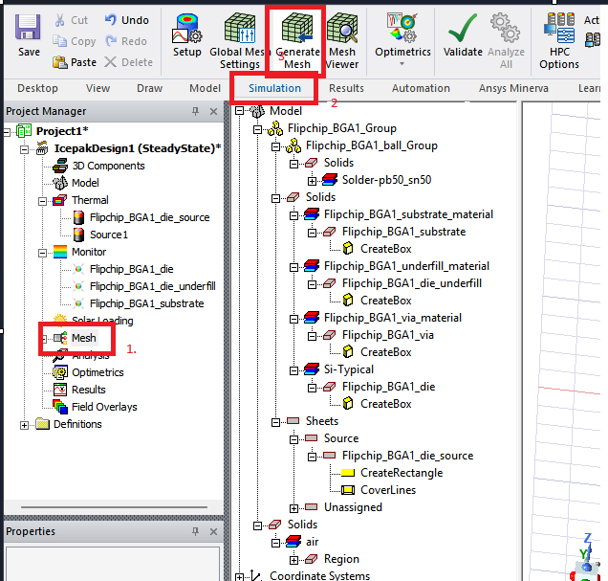

Save

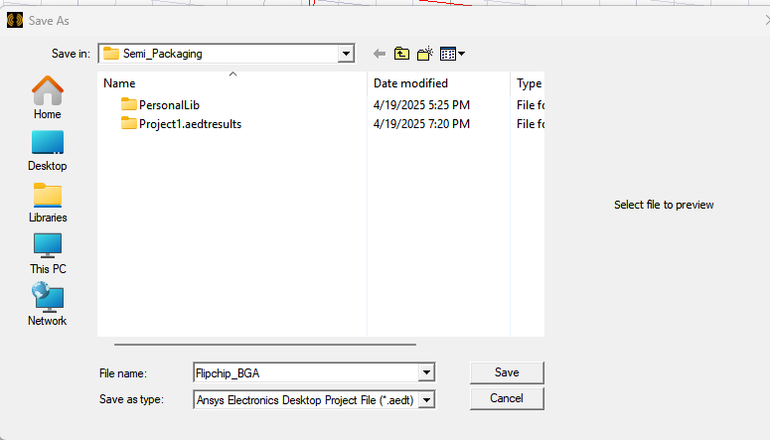

After Mesh run completion -

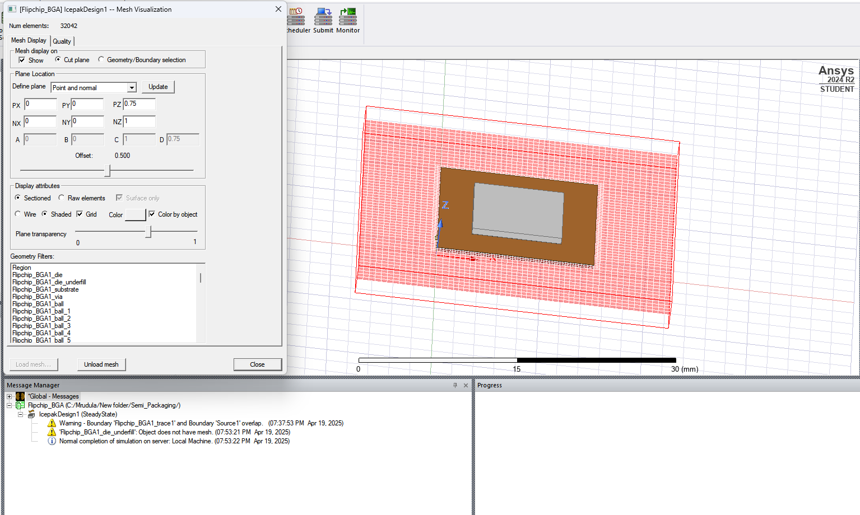

Properties of Mesh -

Face element - alignment - high side number preferable

Skewness - 95% of the cases are quality for the mesh

Mesh Important parameter for accuracy of the simulations

Tip - Mesh can be run on the whole region and a particular region as well, using geometry filters

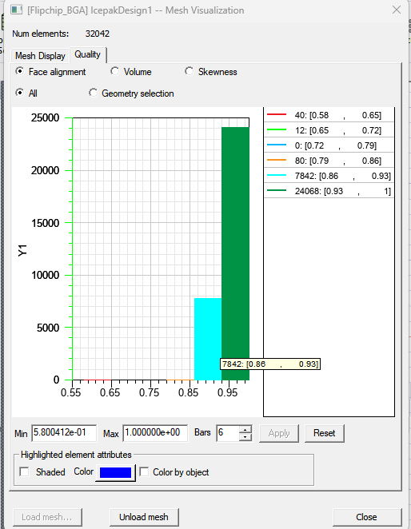

Analysis:

Analysis (right click) -> Add Solution step

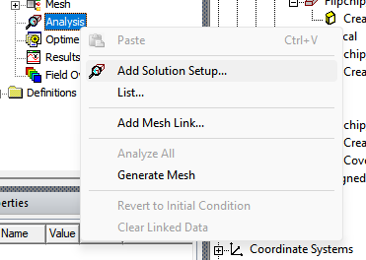

Default Icepak Solution setting

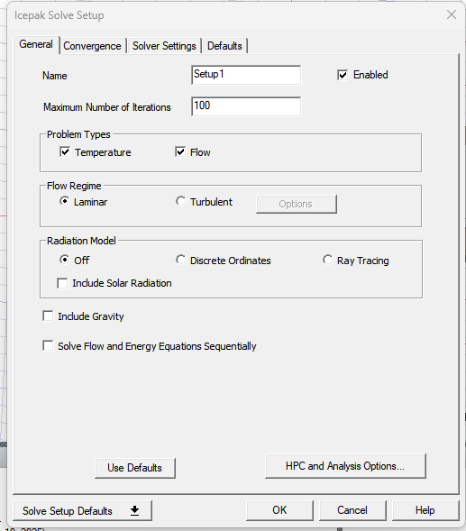

Validate setup -   
  
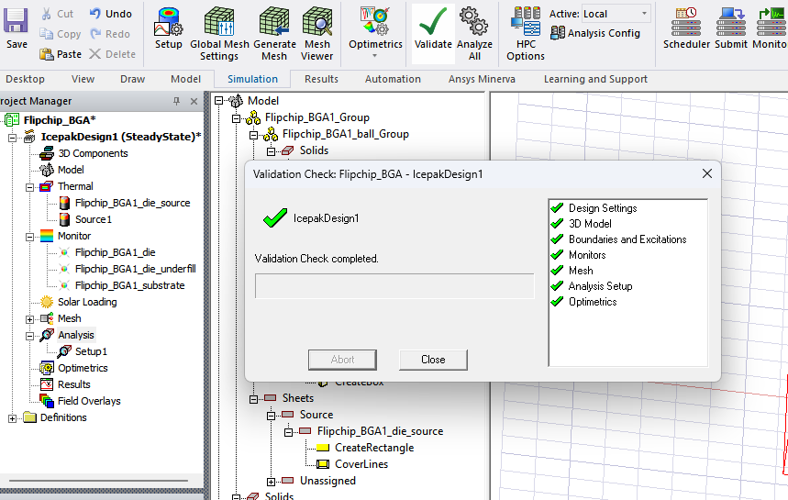

Adjust any warnings -   
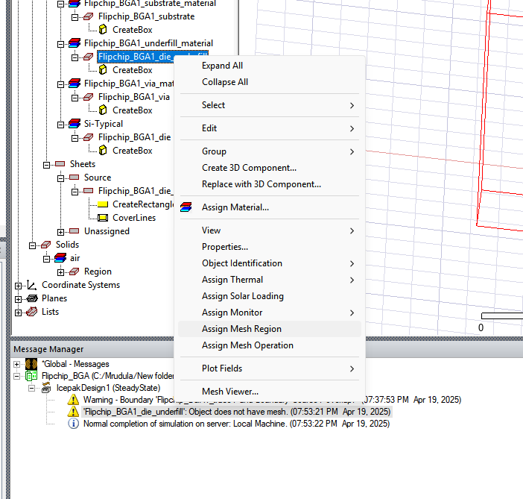

Popup - select from list  
  
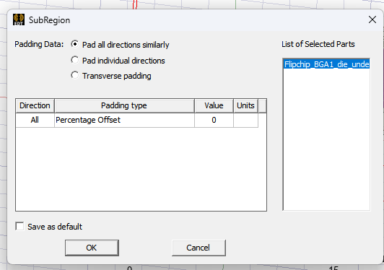

Enable - Mesh Fusion -> OK

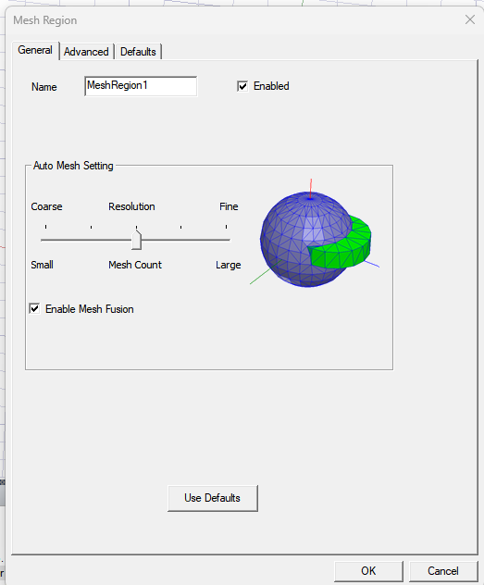

Generate Mesh again for the complete Mesh Operation

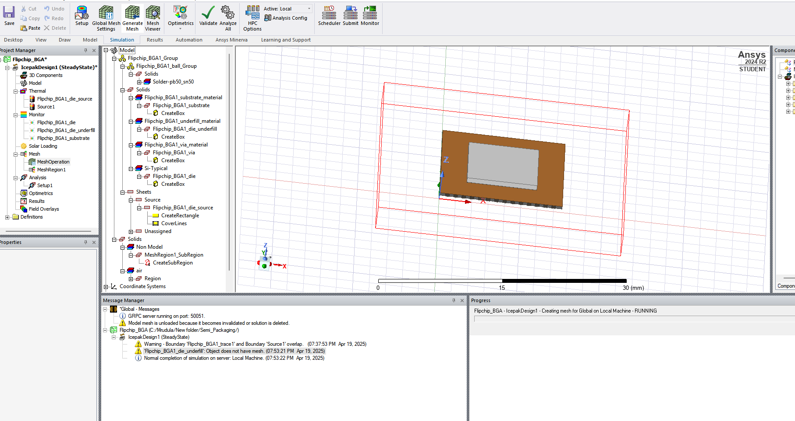

Validate setup again

Now start Calculation - Click on Analyze All 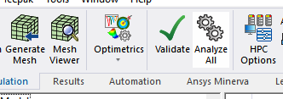

Debug - Mesh region1 causing issues

* Remove Mesh Region
* Generate Mesh again
* Valisate again
* Analyze All again
* Once Normal completion message comes plot graphs

Select the region

Right click -> Plot Fields -> Temperature -> Temperature

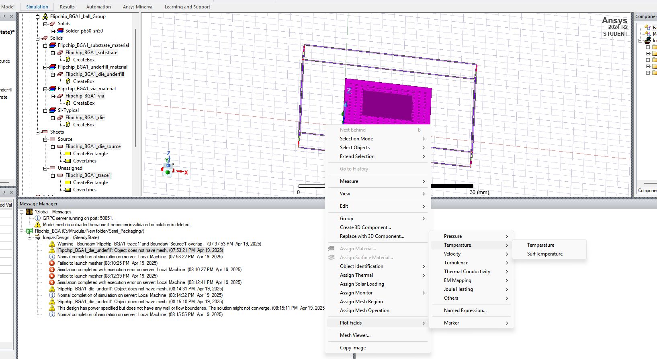

Select 1. Specify Name, 2. Specify Folder, 3. Plot on Surface only

Click Surface Smoothing -> Select Enable Gaussian Smoothing

If additional equation add to field calculator

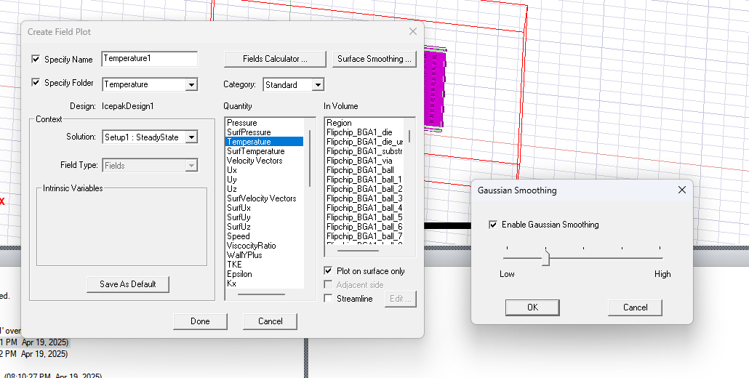

Thermal analysis -

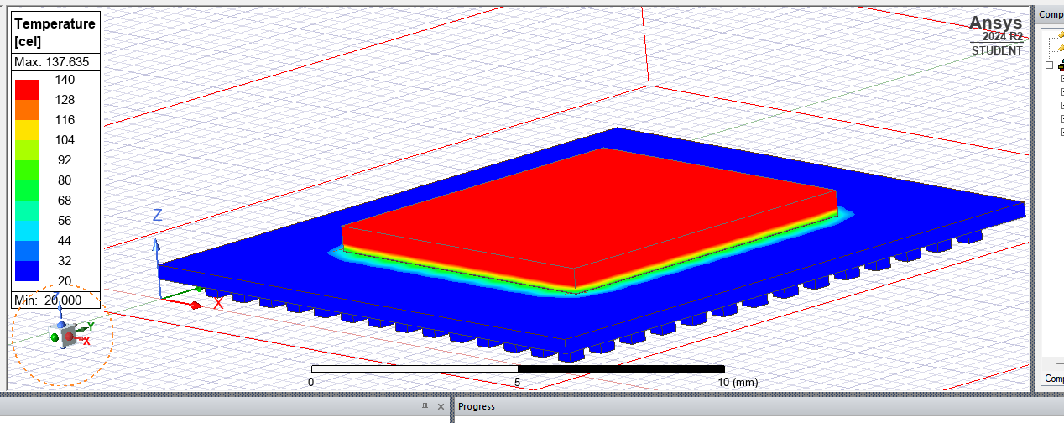

Other packaging models can also be analysed in a similar way.   
QFN - find which bonds are more susceptible to breaking

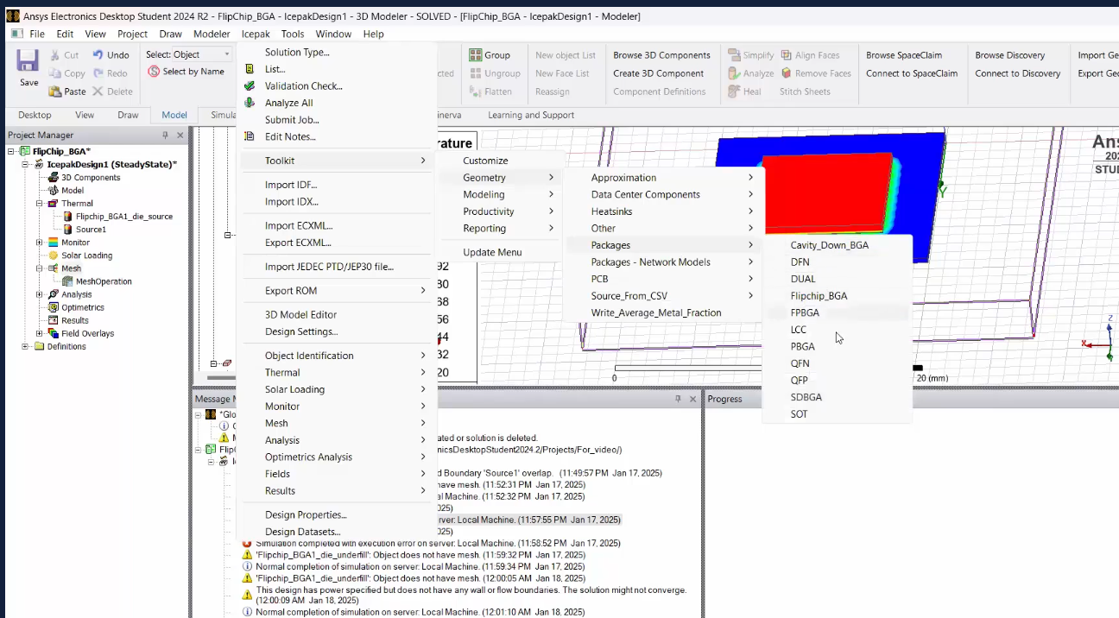

## Summary

🧊 Ansys Icepak Lab: Setup and Thermal Analysis of a Flipchip BGA package.

Below are the steps for setting up an Ansys Icepak and to perform a thermal analysis of a Flipchip BGA package using Ansys Icepak. The simulation is performed for a power input of 1W.

🛠️ Step 1: Insert Icepak Design

* Open Ansys Workbench.
* Navigate to Project -> Insert Icepak Design.
* Click the Icepak tab in the top toolbar to launch the Icepak layout environment.

📦 Step 2: Create a Flipchip BGA Package

* Go to Icepak -> Toolkit -> Geometry -> Packages -> Flipchip_BGA.
* A configuration window will appear.
* Set parameters:  
  xLength: 15 mm  
  yLength: 15 mm  
  Package Thickness: 3 mm  
  Model Type: Detailed  
  Symmetry: Full
* Click OK to generate the 3D model.
* The model will appear in the working space.

📂 Step 3: Explore the Model Structure

* In the Model Tree, expand each section to view:  
  Substrate  
  Die  
  Underfill, etc.

♨️ Step 4: Assign Thermal Power

* Navigate to Project Manager -> Thermal.
* Enter the Power value (e.g., 1 W) and click OK.

🌡️ Step 5: Assign Thermal Sources

* In Solids, select Flipchip-BGA1_substrate.
* Right-click -> Assign Thermal -> Source.
* In the dialog box, set Thermal Condition to Ambient Temperature.
* Click OK.
* Delete any extra element like Flipchip_BGA_trace1 under the Thermal node.

📈 Step 6: Assign Temperature Monitors

* In Solids, select Substrate -> Assign Monitor -> Point.
* Tick Temperature -> Click OK.
* Repeat the same process for the Die and Underfill components.

🧩 Step 7: Generate Mesh

* Go to the Mesh tab.
* Click Simulation -> Generate Mesh.
* Save the file when prompted -> Click OK.

🔍 Step 8: Inspect Mesh Quality

* In Mesh Visualization, click Quality.
* Check parameters such as:  
  Face Alignment  
  Skewness  
  Volume

✅ Step 9: Validate the Setup

* Click Validate from the top menu bar.
* Ensure all validation checks return green ticks.
* This confirms the setup is ready for simulation.

📊 Step 10: Run Simulation and Plot Temperature Field

* Click Analyze All from the top bar.
* Select the Flipchip BGA package.
* Navigate to Plot Field -> Select Temperature -> Choose Temperature.
* Configure Output Options:
* Enable:  
  Specify Name  
  Specify Folder  
  Plot on Surface Only
* In Surface Smoothing, enable Gaussian Smoothing.
* Click OK -> then Done.

A thermal analysis of the Flipchip BGA package is successfully completed for a power input of 1 W.

## Ensuring Package Reliability: Testing and Performance Validation

## Introduction to Package Testing and Electrical Functionality Checks

### Testing at Different Stages

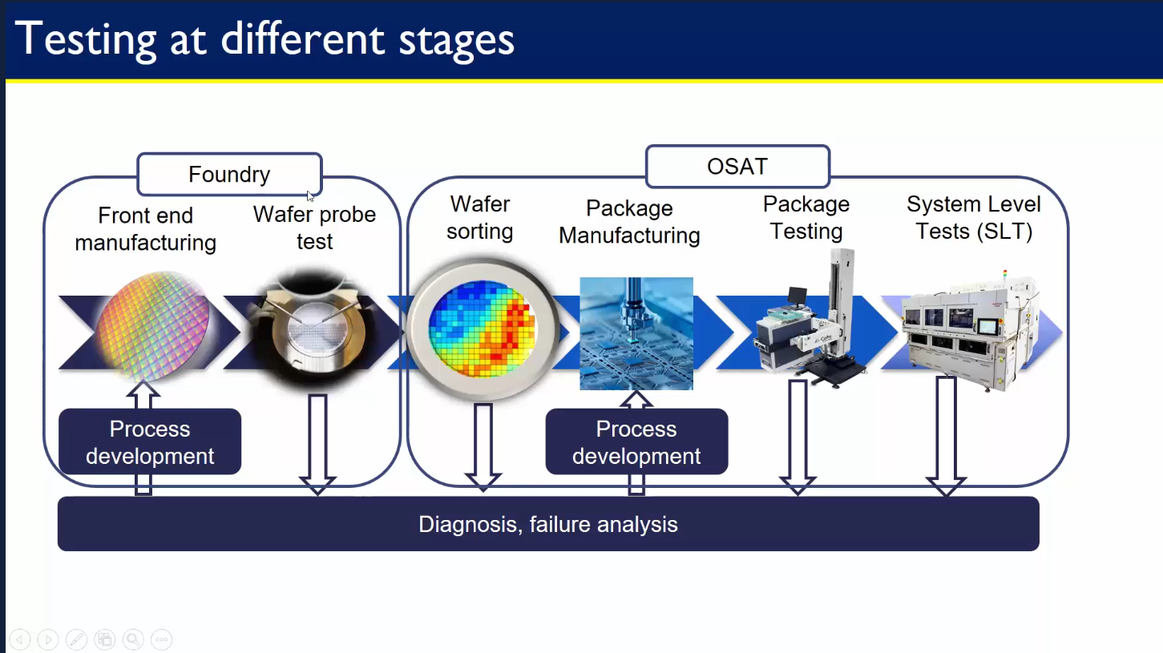Testing is performed at multiple stages in the semiconductor lifecycle to ensure functionality, yield, and reliability — from the wafer level to final product delivery. Testing is conducted at both the Foundry and OSAT (Outsourced Semiconductor Assembly and Test) levels.

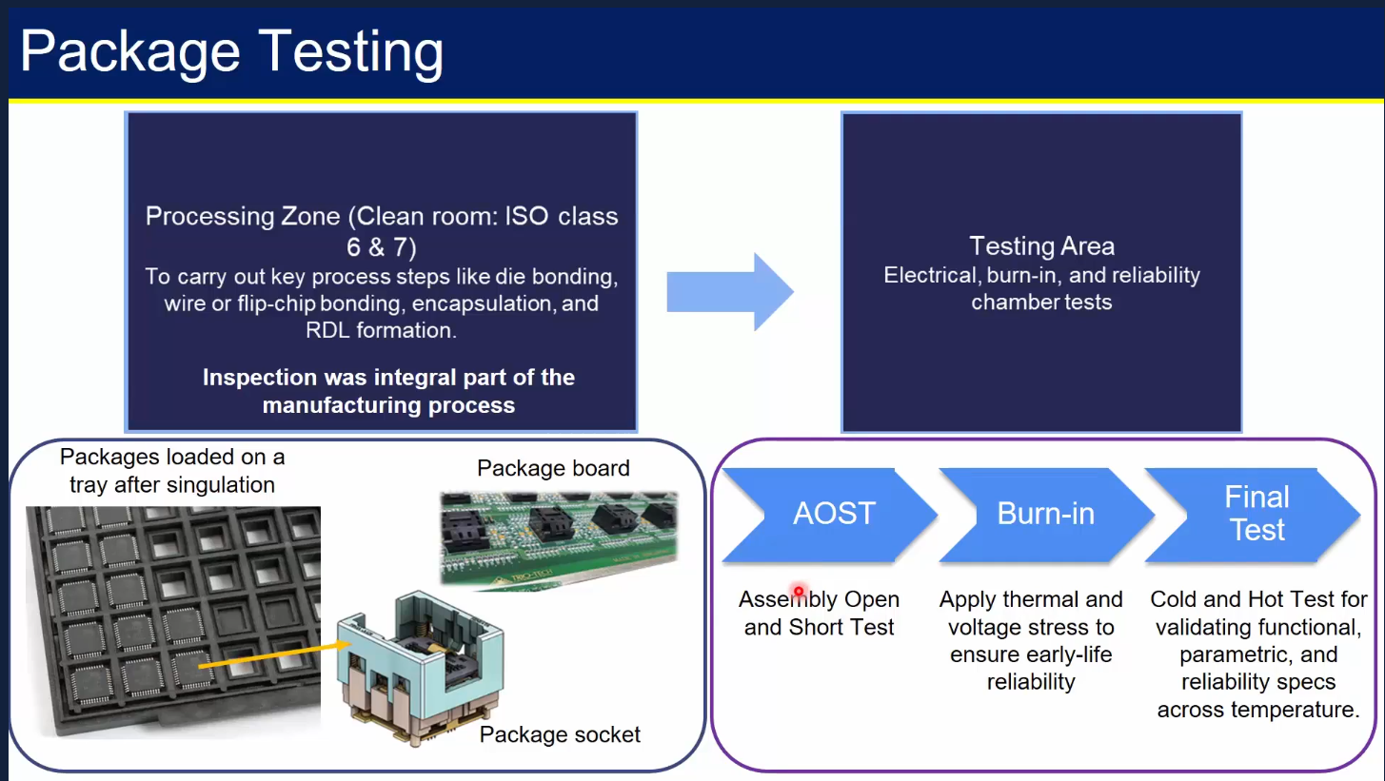

🏭 Foundry Testing Stages

1. Front-End Manufacturing  
   * Involves wafer fabrication and creation of integrated circuits on silicon wafers.
   * Process development ensures quality control and high-yield production.
2. Wafer Probe Test  
   * Use a probe station and ATE (Automated Test Equipment).
   * Each die is tested by contacting the pads/bump sites using a probe card.

🧪 OSAT Testing Stage

1. Package Manufacturing  
   * Functional dies are packaged using techniques like:  
     Die bonding  
     Wire or flip-chip bonding  
     Encapsulation
2. Package Testing  
   * Conducted in ISO Class 6/7 cleanroom zones.
   * Testing includes:  
     AOST (Assembly Open and Short Test): Quick check for opens/shorts in packages.

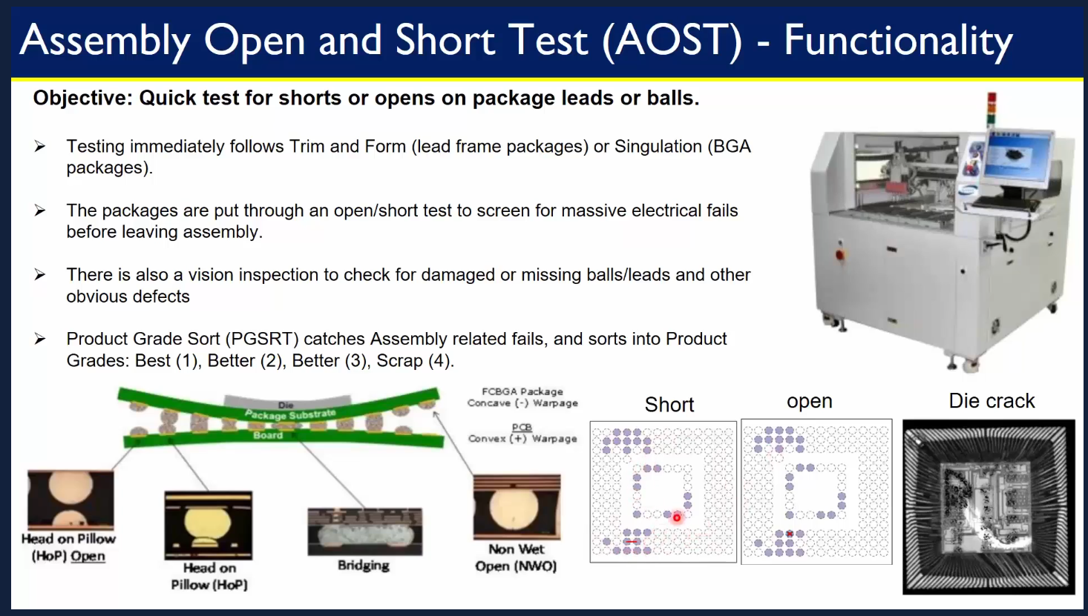

* + Burn-in: Applies voltage and temperature stress to catch early failures. Devices are exposed to high temperature and voltage to accelerate aging.  
    Final Test: Functional and parametric testing across temperature ranges. Post-Packaging Functional Test performed using Automated Test Equipment (ATE). Full chip functionality, I/O operation and signal timing, Power consumption and leakage are all tested.

1. System-Level Test (SLT)  
   * Performed in a real or emulated end-user environment
   * Example: Testing an SoC inside a phone board simulation
   * Checks interactions with memory, sensors, I/O, etc.
   * Purpose: Capture failures that ATE may miss (e.g., timing marginalities, real-world power issues)

## Reliability and Performance Testing of Semiconductor Packages

### Burn-in, Final Test, and ATE Overview

This section provides an overview of various stages involved in the testing of integrated circuits (ICs), focusing on Burn-in Testing, Final Testing, and the use of Automatic Test Equipment (ATE).

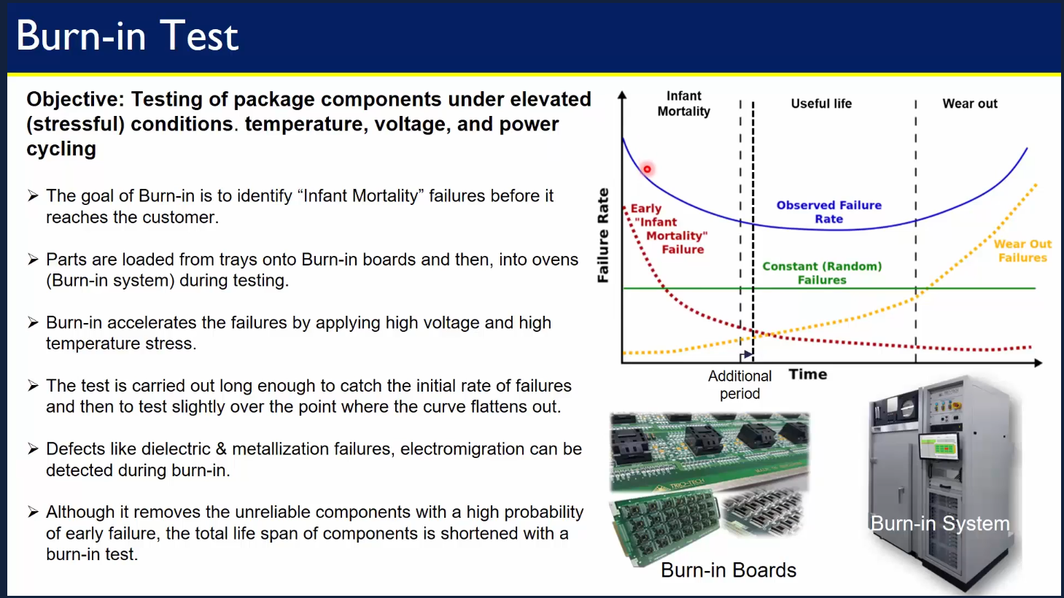

🔥 Burn-In Test  
Burn-in testing is a reliability screening process where semiconductor devices are exposed to elevated temperatures, voltages, and operating conditions for an extended period to accelerate aging and failure mechanisms. It is used to identify and eliminate early-life failures (also called "infant mortality") in ICs before they are shipped to end users. Observed failure rate - Bath tub curve,

🎯 Purpose of Burn-In Testing

* Detect latent manufacturing defects
* Improve long-term product reliability
* Ensure performance under extreme conditions
* Qualify devices for mission-critical applications

🔁 Typical Test Conditions:

* Temperature 125°C to 150°C (sometimes higher)
* Voltage 1.5× to 2× normal operating voltage
* Duration 24 to 168 hours (1–7 days)
* Environment Controlled chamber or oven with power applied

✔️ Common in:

* Automotive-grade ICs (AEC-Q100 compliance)
* Medical electronics
* Aerospace and defense
* Enterprise-grade processors and FPGAs

❌ Less common in:

* Consumer electronics (phones, laptops) due to cost and time constraints

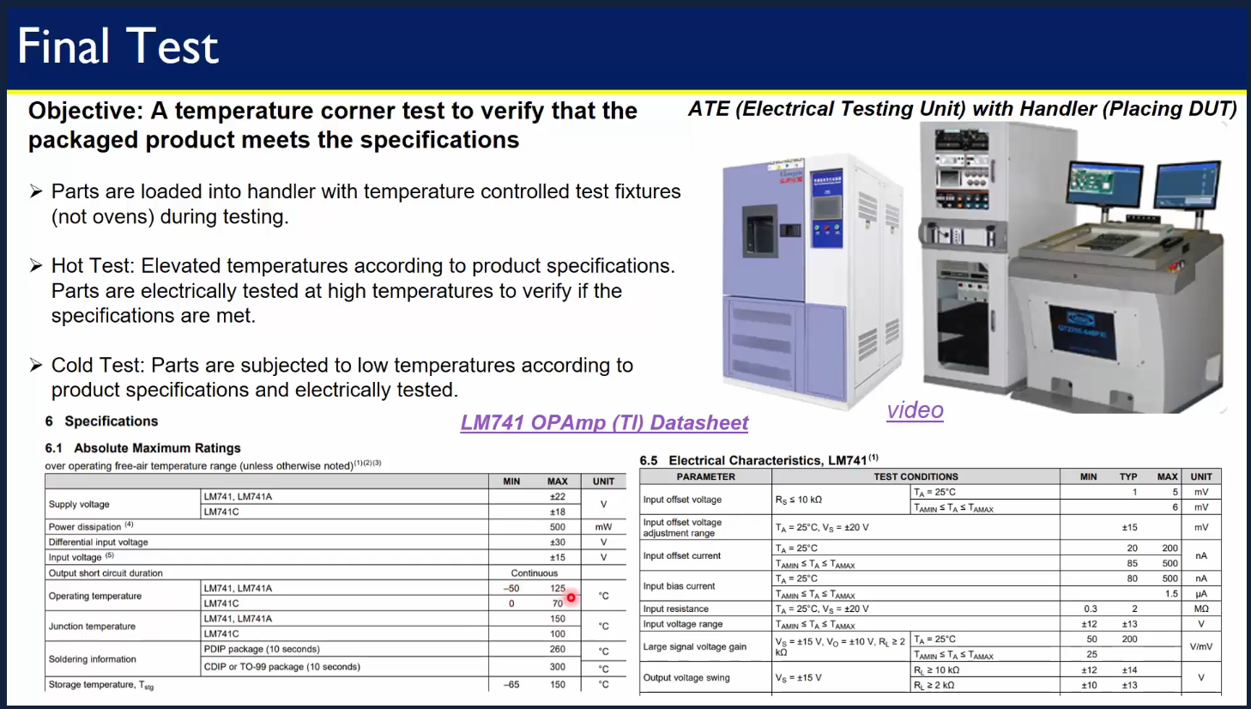

✅ Final Test (FT) – Semiconductor Testing After Packaging  
Final Test is the last major electrical test phase after the semiconductor die has been packaged. It verifies that the packaged device meets all functional, parametric, and performance specifications before it is shipped to customers. It is typically performed by OSATs (Outsourced Semiconductor Assembly and Test providers) or in-house test facilities.

Test flow:

1. Device Loading  
   * Packaged ICs are loaded into automated test handlers.
   * Handlers place each device into a test socket.
2. ATE Interface  
   * Devices are connected to ATE (Automated Test Equipment) which applies: Voltage/current, Digital patterns, Analog/RF stimuli (if applicable)
3. Test Execution  
   * Tests include:  
     DC tests – leakage current, voltage thresholds  
     AC tests – timing, propagation delay, clock performance  
     Functional tests – logic operations, memory read/write  
     Parametric tests – power consumption, I/O voltage levels
4. Binning  
   * Devices are classified (binned) based on performance: Speed grade, Power grade, Pass/fail
5. Marking and Packing  
   * Passed devices are laser-marked, packed in trays or reels, and sent for shipment.

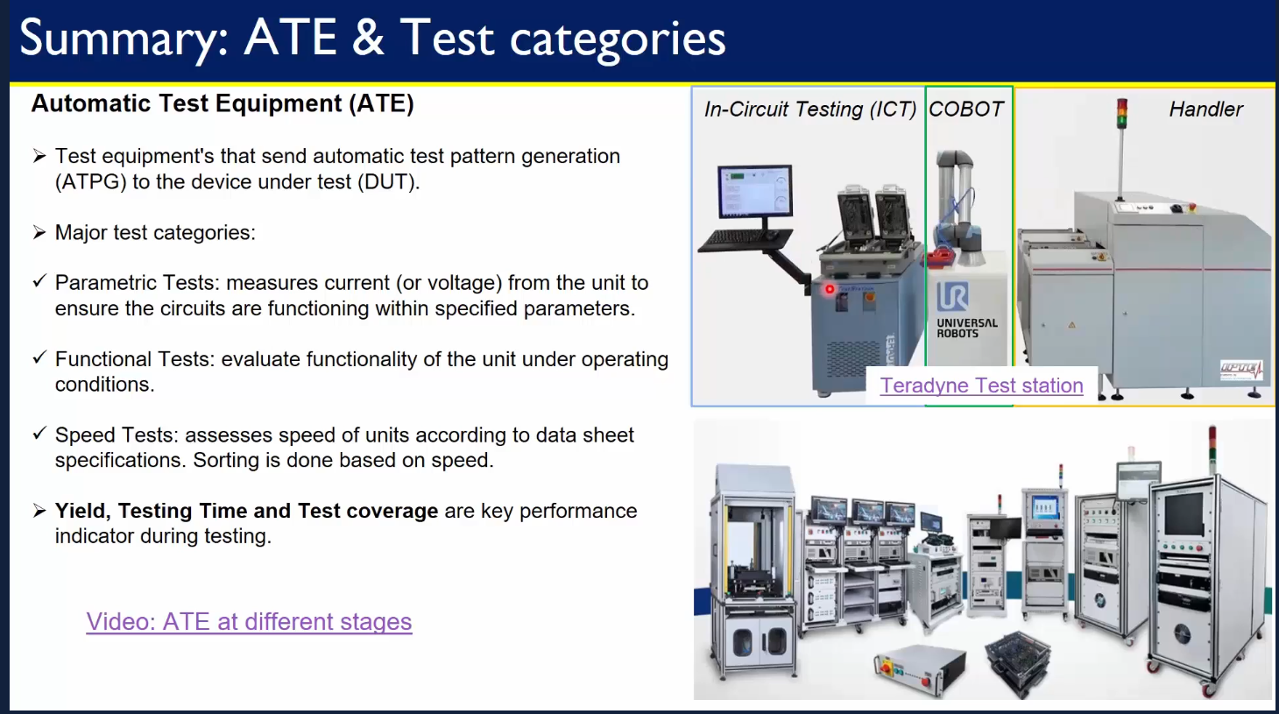

🤖 Automated Test Equipment (ATE) – Semiconductor Device Testing  
ATE (Automated Test Equipment) refers to a computer-controlled system used to test semiconductor devices — both before (wafer level) and after packaging — to ensure they meet required electrical and functional specifications. ATE systems are the heart of functional and parametric testing in both wafer sort and final test stages.

Categories of ATE Tests:

* Parametric Tests: Measures current/voltage to check if circuits operate within limits.
* Functional Tests: Validates if the IC performs correctly under normal conditions.
* Speed Tests: Measures processing speed; parts are sorted accordingly.  
  Key Performance Indicators:
* Yield
* Testing Time
* Test Coverage  
  Equipment Examples:
* In-Circuit Tester (ICT)
* COBOT (Collaborative Robot)
* Handler Units

## Package Design and Modeling: Building a Semiconductor Package from Scratch

## Introduction to Package Cross-Section Modeling in ANSYS Electronics Desktop

The objective is to create package cross-section in ANSYS AEDT. This lab focuses on designing a semiconductor wire bond package from scratch using Ansys Electronics Desktop (AEDT). The complete cross-section of a wire bond package, including die, substrate, bonding wires, and mold compound is modeled.

Package Manufacturing Flow:

🧾 1. Wafer Reception - Fully processed wafer (typically 200 mm or 300 mm) from the foundry. Wafer ID, surface condition, and warpage are checked. Wafer is stored in Front Opening Unified Pods (FOUPs) or cassettes to avoid contamination.  
🔍 2. Wafer Backgrinding - Reduce wafer thickness to meet package size constraints. Front side is laminated with protective tape. Backside grinding reduces thickness.  
✂️ 3. Wafer Dicing / Singulation - Separate the wafer into individual dies (chips) by Blade dicing (mechanical) or Laser grooving + breaking (preferred for small pitches).  
🔗 4. Die Attach - Attach each die to a substrate or leadframe using methods like Epoxy dispensing or die attach film (DAF). Die is cured via thermal or UV process.  
🔌 5. Interconnect / Die-to-Package Connection - Two main technologies: Wire Bonding (Wires (Au, Cu, or Al) connect die pads to package leads, Common in QFN, SOP, and some BGA packages) & Flip-Chip Bonding (Die is flipped; solder bumps on die connect directly to the substrate, Used in FCBGA, WLCSP, 2.5D/3D ICs).  
🧱 6. Encapsulation / Molding - Protect the die and wires with Epoxy Molding Compound (EMC).  
✒️ 7. Marking - Laser or ink marking is applied to the top of the package used to identify Lot number, Product ID, Manufacturing code, Traceability code etc..  
🪓 8. Package Singulation (Post-Mold Dicing) - Multiple packaged dies on a strip are singulated into individual units. Dicing saw or laser is used to cut molded panels.  
🧪 9. Final Test / Electrical Testing - Packaged ICs are tested using ATE systems. Devices are binned and sorted.  
📦 10. Packing & Shipping - Devices are packed in JEDEC trays, tape-and-reel, or bulk. Labeled with date code, lot ID, and destination details. Ready for shipment to OEMs or ODMs.

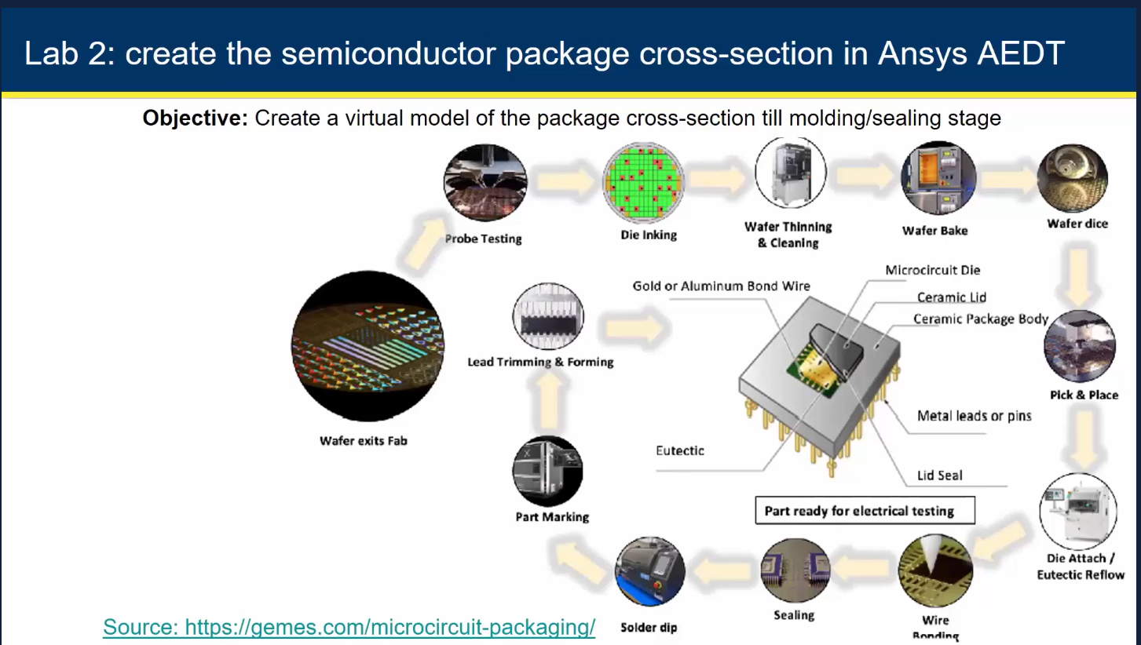

Why Package 3D cross section is needed ?

Thermal analysis is just one aspect of evaluating a package’s overall performance. Equally important is electrical performance, which plays a critical role during the package design phase. Tools like ANSYS Q3D Extractor and Maxwell are commonly used for electrical analysis in this context. However, in this lab, the primary focus will be on building the package structure from the ground up, rather than conducting in-depth electrical or thermal simulations.

## Creating the Die and Substrate in AEDT

### 🛠️ Steps to Create a Die in ANSYS

Step 1. Launch ANSYS Electronics Desktop (AEDT)

* Choose a project type: Icepak, HFSS 3D Layout, or **Q3D Extractor for die**
* Create a new project and insert a new design (e.g., Icepak for thermal, HFSS for EM)
* Define the Working Units: Go to Modeler → Units
* Set units to mm (or μm) for package-scale modeling

Step 2. Create the Die Geometry

* Use Draw → Rectangle to create the die (chip)
* Set the dimensions as 3mm x 3mm and the positions (0,0,0) for center
* For thickness, apply 0.2mm (after thinning). Modeler -> Surface -> Thicken Sheet and set the thickness as 0.2mm
* Check Material -> SIlicon
* Pro Tip: Name it clearly (e.g., Die)

Note - HBM are connected by TSV and are very very thin typically ~ 30microns. General die size ~15um x15um to 20um x20um

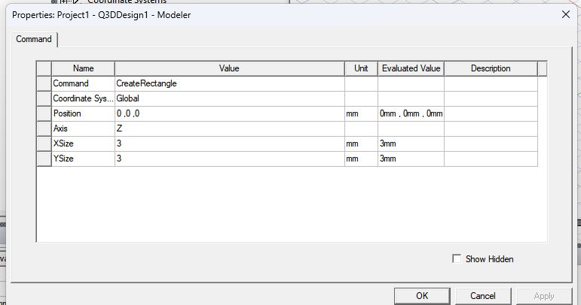

Step 3: Assign Material Properties

* Go to Modeler → Assign Material
* Choose Silicon from the material library (or create a custom material)
* Assign it to the die geometry

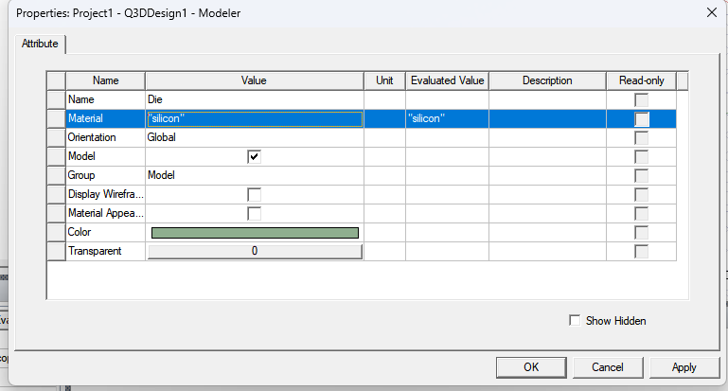

Final die structure

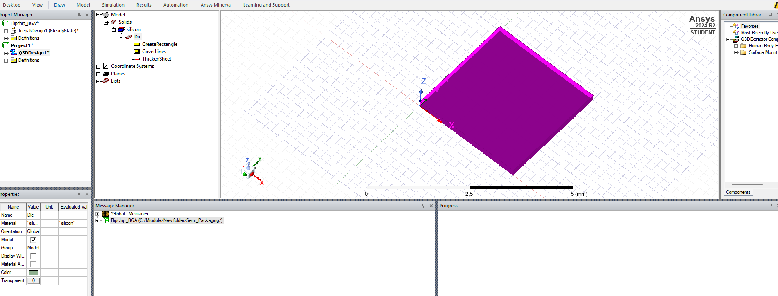

### 🛠️ Steps to Create a Substrate in ANSYS

Step 4. Create the Substrate Geometry

* Create another rectangle for the substrate (e.g., 5mm x 5mm)
* Position the substrate such that the die is at the center (e.g., -1, -1, -0.1) z space for die attachment between
* Modeler -> Surface -> Thicken Sheet and set the thickness as -0.5mm (0.5mm would hide the die, in order to put substrate on bottom of die -0.5mm)
* Material -> FR4_Epoxy

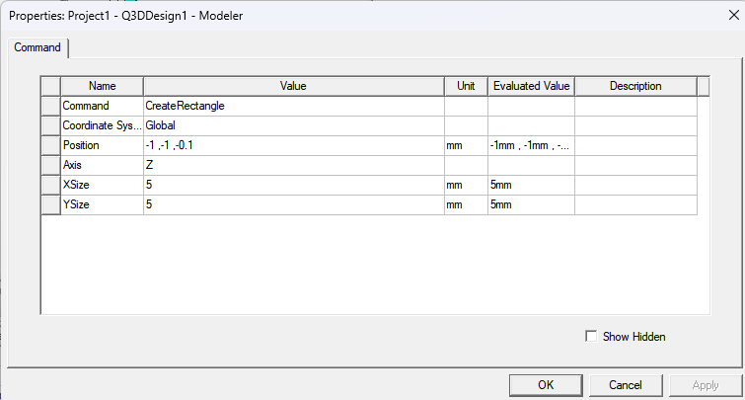

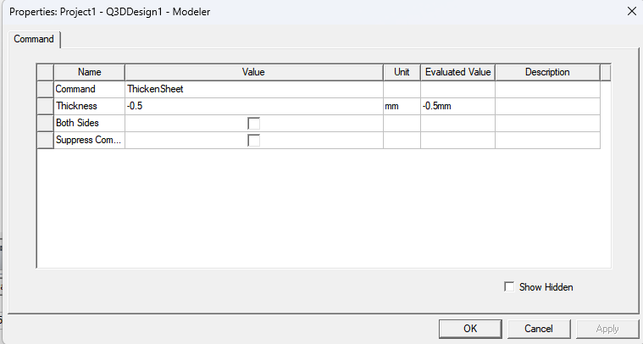

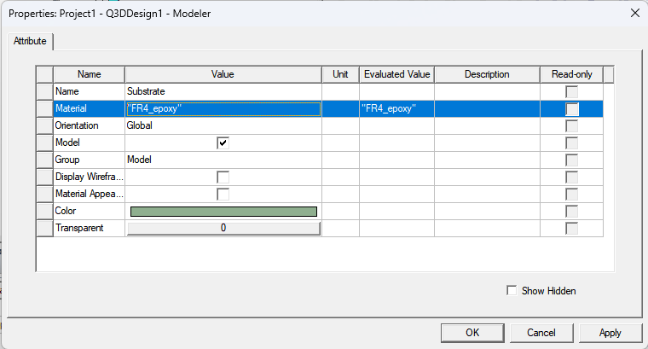

The space between the die and substrate in the below figure is for die attach material.

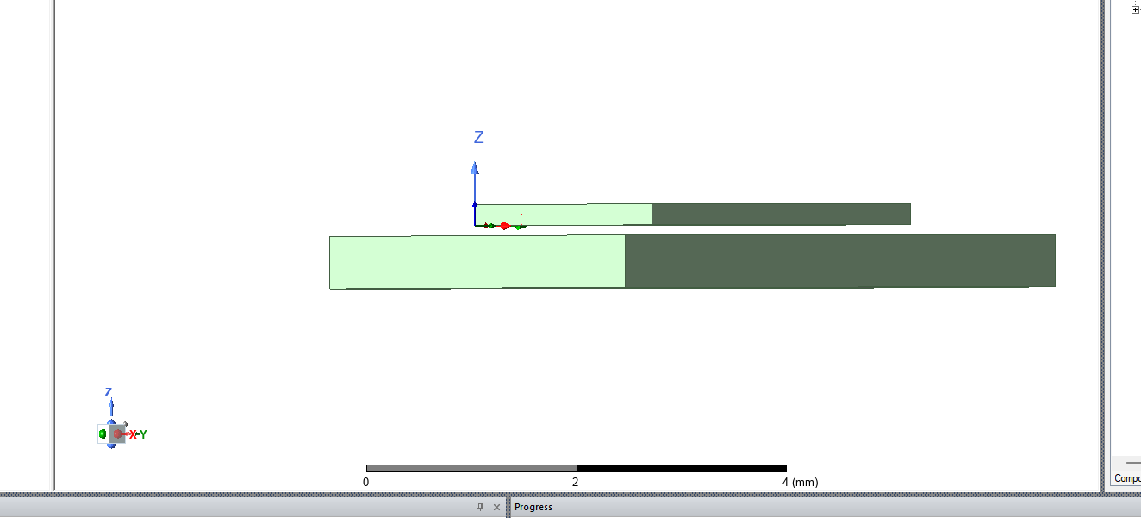

## Adding Die Attach Material and Bond Pads

### 🛠️ Steps to Create a Die Attach Material

Step 5: Create the DAM Geometry

* Create another rectangle same size as die at origin (0,0,0) to represent die attach epoxy
* Set thickness: -0.1 mm
* Assign appropriate material such as modified_epoxy for thermal conductivity simulation

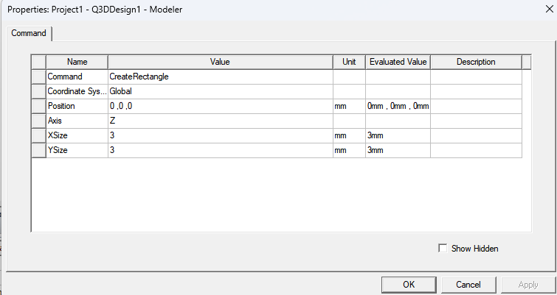

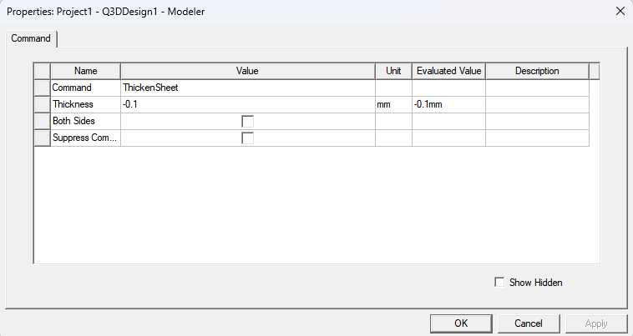

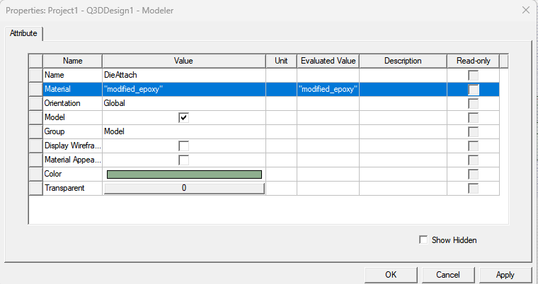

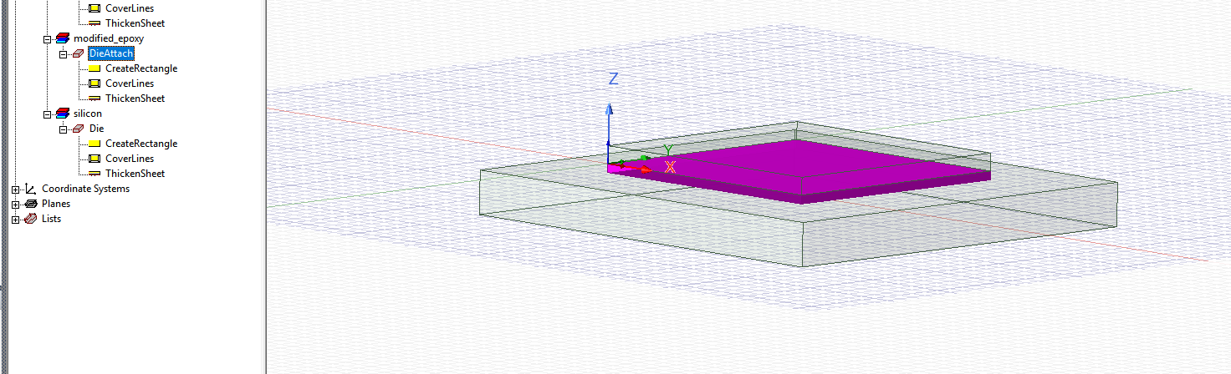

### 🛠️ Steps to Create Bond Pads

Step 6: Define Die Pads

* Create a thin rectangle to represent the die pad of dimensions 0.2mm x 0.2mm
* Set thickness: 0.005 mm
* Similarly create pads on the substrate

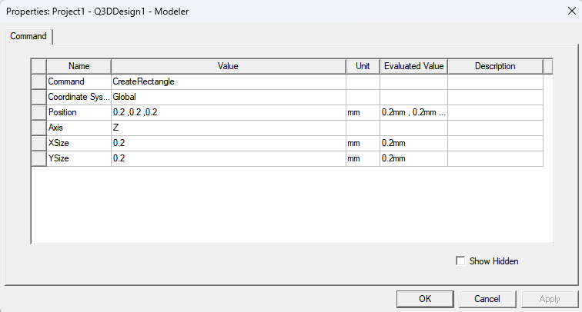

Step 7: Create bond pads on both die and substrate

* Create the pads across the periphery of the die and substrate as shown in the below figure
* These will serve as connection points
* Assign material (typically metal types like copper, gold or aluminum)

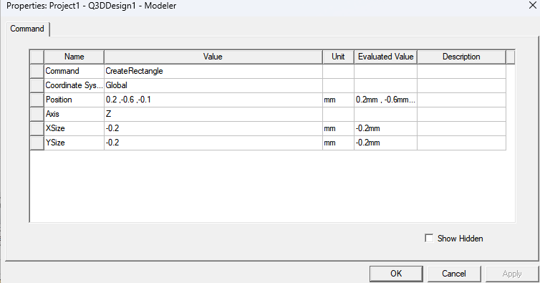

## Wire Bond Creation and Material Assignment

### 🛠️ Steps to Create Bond Wires

Step 8: Connect pads using wires

* Draw -> Bondwire
* Connect the die pads to substrate pads using gold wire

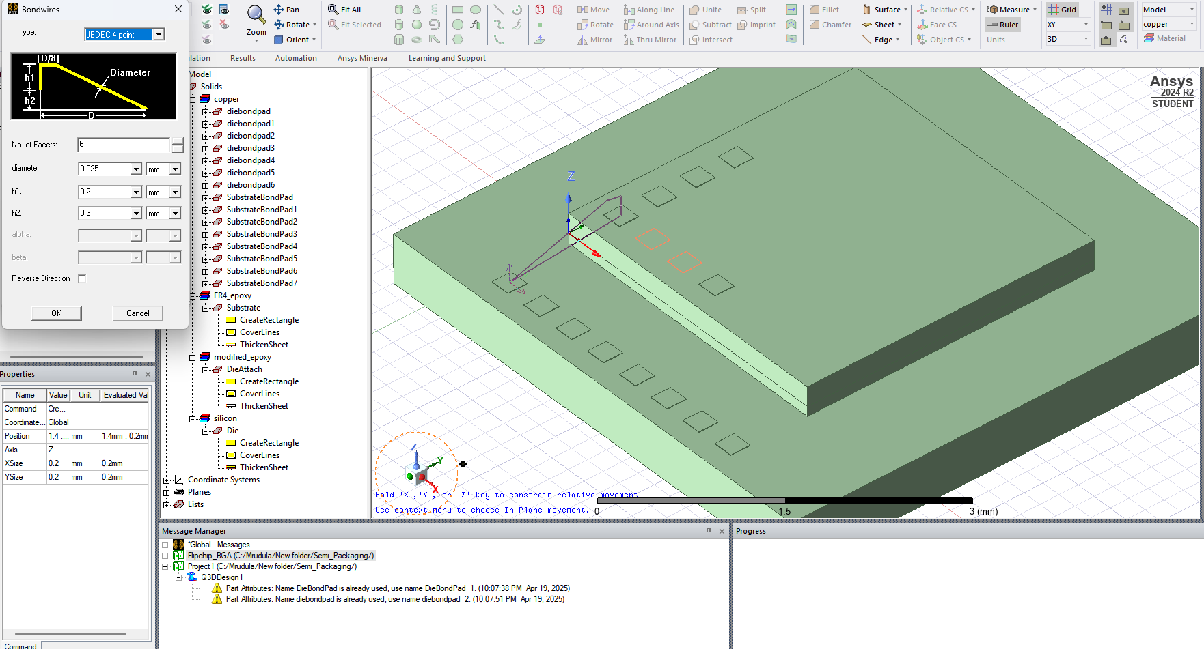

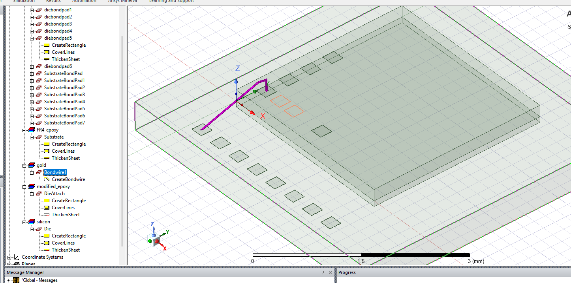

## Applying Mold Compound and Finalizing the Package Model

### 🛠️ Steps to Create Mold Compound

Step 9: Build mold around the die

* Add a rectangular mold compound to encapsulate the die and wire bonds
* Set thickness: 1.2 mm
* Assign mold material (e.g., epoxy molding compound)

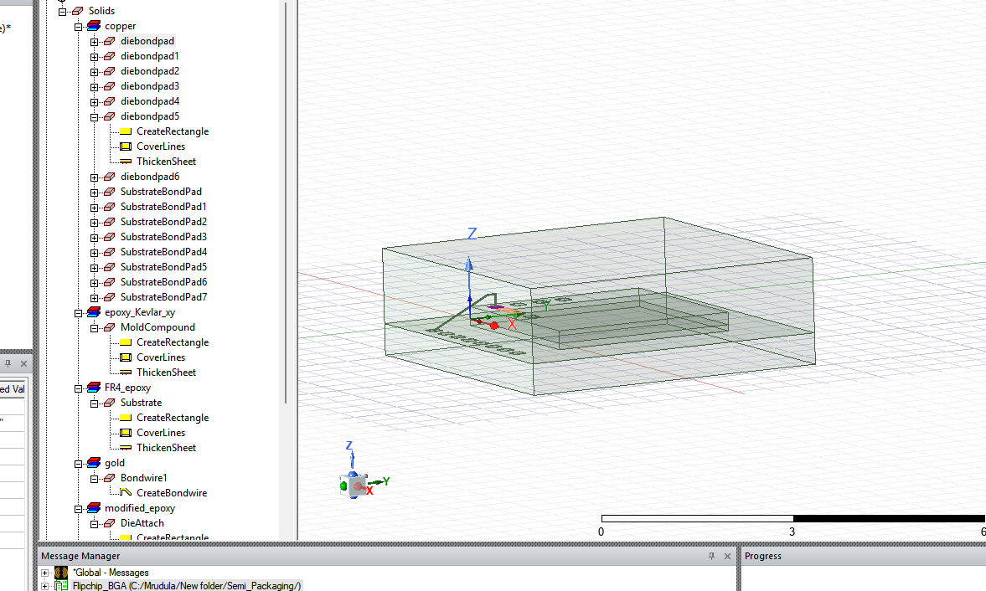

Step 10: Post molding, attach solder balls. Define power dissipation for the die and Set boundary conditions. Set up mesh operations and run simulation (thermal or EM). Visualize temperature distribution, current density, or EM fields

## Conclusion: Semiconductor Packaging

Semiconductor packaging is no longer just about protecting the chip—it's a key factor in enabling performance, reliability, and integration. As device complexity increases, packaging must meet demanding electrical, thermal, and form-factor requirements. From traditional leadframe designs to advanced solutions like FCBGA, 2.5D/3D, and wafer-level packaging, the choice of package plays a strategic role in product success.

With the rise of chiplets, heterogeneous integration, and shrinking form factors, packaging is now a vital part of the innovation pipeline—bridging the gap between silicon design and system performance.